WaterWise: An Integrated Water Distribution Management and Decision Support System for Sucol Water System

A Capstone Project Presented to the Faculty of
College of Informatics and Computing Sciences
Batangas State University – The National Engineering University
Balayan Campus
Batangas

In a Partial Fulfillment
of the Requirements for the Degree
Bachelor of Science in Information Technology
with Specialization Track in Business Analytics

Iverene Grace M. Causapin
Kyle Cedrick A. Ferrer
Jaycee Hernandez

May 2026

APPROVAL SHEET

This Capstone Project titled WaterWise: An Integrated Water Distribution Management and Decision Support System for Sucol Water System, prepared and submitted by Iverene Grace M. Causapin, Kyle Cedrick A. Ferrer, and Jaycee Hernandez, in partial fulfillment of the requirements for the degree of Bachelor of Science in Information Technology with Specialization Track in Business Analytics, is hereby accepted.

Mr. Mark Anthony P. Ribaldo
Adviser

Approved by the Committee on Oral Examination with a grade of ________

Ms. Celinne A. Mendez
Chair, Defense Panel

Mr. Gerard James Q. Daño Ms. Ria L. Castillo
Panel Member Panel Member

Accepted and approved for the degree Bachelor of Science in Information Technology with Specialization Track in Business Analytics.

________________ Dr. Princess Marie B. Melo
Date Dean, CICS

- INTRODUCTION
This chapter will discuss the background of the study, its objectives to attain, significance, and the scope and its limitations.
1.1 Background of the Study
Water is considered one of the most important resources needed in our daily lives. It is needed not only for drinking and cooking but also for other activities such as agriculture, where more water is consumed. Many of our daily household activities, such as dishwashing, washing clothes, bathing, cleaning the house or vehicles, cooking, and so on, require the use of water (Ogunbode et al., 2023). Therefore, it is important to have a water supply system in any place. If we closely examine how irrigation water is currently collected, it is still done manually. This method causes problems in recording water consumption and billing consumers. It is difficult to monitor water usage and balance with this method.
In Sucol, Balayan, Batangas, the local water system plays a vital role in providing households with access to a stable water supply. However, the management of water consumption recording, billing, and payment transactions is still conducted manually. Every month, the assigned meter reader visits each consumer’s house to check and record the current water meter reading in a logbook. After gathering the readings, the personnel manually compute the water consumption and corresponding water bill of each consumer based on the recorded data. The computed bills are then prepared manually for collection. For payment transactions, consumers personally visit the barangay outpost to settle their water bills, where payments are manually recorded and updated in the logbook and barangay records.
Although this process helps maintain consumer and billing records, it is labor-intensive, time-consuming, and prone to human error, especially when handling a large number of consumers. Delays in updating payment records may also cause inaccuracies in identifying paid and unpaid accounts, which can sometimes result in confusion regarding consumer balances and water service disconnection. In addition, the manual recording and computation process makes data organization, monitoring, and retrieval difficult for the personnel of the Sucol Water System. Manual recording of water consumption is time-consuming, prone to human error, and inefficient in terms of data management. It limits accessibility, delays report generation, and makes it difficult to analyze consumption trends, leading to less effective monitoring and decision-making (Mencias et al., 2024). These challenges may affect the efficiency of daily operations and limit the ability of the management to effectively monitor water consumption, track payment statuses, and maintain organized records. As the number of consumers increases, the limitations of manual processing become more evident, creating delays and reducing the overall reliability of the system.
To address these issues, there is a need for a more efficient and intelligent water management approach that enhances data accuracy and supports better decision-making. The integration of a centralized web-based platform with Decision Support System (DSS) capabilities presents a practical approach to addressing these operational challenges. By shifting from manual recordkeeping to digital data management, water consumption records, billing information, and payment transactions can be stored, processed, and monitored more efficiently and accurately. In addition, the incorporation of analytical and reporting functionalities can provide valuable insights into water consumption patterns, payment trends, and operational performance, supporting more informed planning and decision-making. Through the adoption of a digital and data-driven approach, water utility management can achieve improved operational efficiency, enhanced accuracy in data processing, reduced human error, and more reliable monitoring of consumer and billing records. Furthermore, this system will incorporate artificial intelligence features such as demand forecasting to predict future water usage based on historical data and intelligent recommendations to support usage optimization.
1.2 Objectives of the Study
The general objective of the study is to design and develop Water-Wise: A Web-Based Water Management and Decision Support System for Sucol Water System that will automate the management of consumer records, meter readings, billing computation, payment monitoring, and balance tracking to improve the efficiency, accuracy, and reliability of water service operations.
Specifically, it aims to achieve the following objectives:
- To develop an Administrative Management Portal for the Sucol Water System administration by implementing:
  - Role-Based Access Control (RBAC) for administrators and meter readers
  - Consumer Record and Meter Reading Management
  - Automated Billing Computation and Payment Transaction Logging
  - Barangay Event-Tagging Mechanism for logging community activities and operational events
  - Centralized Dashboard for Collection Tracking, Water Consumption Monitoring and PDF Report Generation
  - Announcement Creation and Broadcast Management for broadcasting water interruptions, maintenance activities, and administrative updates
- To develop a Web-Based Consumer Portal featuring:
  - Consumer Account Profile
  - Billing and Payment History Access
  - Water Consumption Monitoring
  - Balance Tracking and Digital Receipt Viewing
  - Notifications for Account Billing and Administrative Announcements
- To integrate Intelligent Decision Support Services that will include:
  - Interactive data visualization dashboards for monitoring historical consumption trends, monthly and yearly overall comparison, and purok-by-purok usage patterns;
  - Intelligent demand forecasting to project future water utility requirements based on longitudinal data;
  - Smart administrative recommendations to provide actionable operational insights based on analyzed data.

1.3 Scope and Delimitations
This study focuses on the design and development of an integrated web-based water distribution monitoring and decision support system for Sucol Water System. Its primary aim is to assist the management of the Sucol Water System in improving the recording, monitoring, and management of consumer information, water consumption, billing, and payment transactions through a centralized digital platform.
The system is designed to provide a structured and organized environment for managing water service records, including consumer information, water meter details, monthly meter readings, billing records, payment transactions, and consumer balances. The proposed system will replace the existing manual logbook-based process currently used by the Sucol Water System. Through the system, authorized personnel will be able to digitally record and monitor monthly meter readings, automatically compute water consumption and billing amounts, record payments, and track unpaid balances more efficiently and accurately.
To assist the Barangay Officials and personnel of the Sucol Water System in decision-making and operational planning, the proposed system will utilize interactive dashboards and Decision Support System (DSS) features for monitoring and analyzing water consumption and payment data. These features include historical trend analysis, monthly and yearly water consumption comparisons per purok, consumer usage monitoring, forecasting of future water consumption based on historical records, and AI-driven recommendations for resource optimization and operational water management. By integrating these analytical tools alongside an event-tagging mechanism—which contextually links consumption spikes or drops to localized community activities, seasonal variations, pipeline maintenance periods, or public events—the system can provide highly organized reports and data-driven insights. This contextual framework ensures that the management can distinguish between legitimate demand shifts supporting better monitoring of water service operations, payment tracking, resource planning, and overall management decision-making. Furthermore, the DSS component of the system will help the management interpret collected data more effectively for improved planning and operational efficiency within the Sucol Water System.
The proposed system will be deployed as an installable Progressive Web Application (PWA) accessible across computers, laptops, and mobile devices, providing a responsive and unified cross-platform interface for all user roles. The primary users of the system include authorized personnel—specifically Barangay Officials, Meter Readers, and Consumers of the Sucol Water System—who are responsible for managing consumer accounts, recording meter readings, processing billing and payments, and monitoring localized water consumption trends.
By implementing a system-wide Progressive Web Application (PWA) architecture, the platform enables offline functionality across all user roles via service workers and client-side caching. Field inputs and user data recorded without internet connectivity are stored locally and automatically synchronized with the central database once network access is restored.
However, the study has several limitations. First, the system relies on manual encoding of meter readings by authorized personnel and does not include IoT devices or automated real-time water monitoring sensors. Thus, the accuracy of the system relies on the proper and consistent accuracy of the encoded data. Second, the study is limited to the monitoring, recording, computation, and analysis of water service transactions and does not include automated control of physical water distribution facilities or infrastructure.
However, there are certain limitations to this study. First, the proposed system will rely on digital data entry of submeter readings, as it does not include automated sensors or IoT-based real-time data collection devices. As such, the accuracy of the system will depend on the correctness and consistency of the data encoded by authorized personnel. Second, the system will not include automated control of water distribution or physical system adjustments, as it is limited to monitoring, recording, and analysis only. Lastly, the forecasting and analytical features of the system are dependent on the availability and quality of historical data recorded within the system.
1.4 Significance of the Study
The development of Water-Wise: A Web-Based Water Management and Decision Support System for Sucol Water System is expected to provide significant benefits to the management and personnel of the Sucol Water System by addressing the inefficiencies and challenges associated with manual recording, monitoring, billing, and payment management processes through the use of modern digital solutions.
This study aims to be beneficial to the following:
Barangay Officials. The study will provide Barangay Officials with a centralized digital platform for managing consumer records, meter readings, billing information, payment transactions, and water consumption data of the Sucol Water System. Through organized digital records and automated billing and payment monitoring, the officials can more efficiently manage daily water service operations and reduce errors caused by manual recording and computation. In addition, DSS and analytics features will provide historical reports, water consumption analysis, forecasting, and system-generated insights that will support planning, monitoring, and decision-making for the improvement of water service operations within the barangay.
Meter Reader. The system will significantly improve the workflow of the assigned meter reader by replacing manual logbook recording with a digital recording process through a Progressive Web Application (PWA). Using mobile devices, the meter reader can directly encode monthly meter readings during field visits to consumers. Also, the PWA will enable offline data entry in areas where the internet connection is weak or nonexistent and automatically sync the data once the internet connection is restored. This feature helps ensure continuous and accurate data collection while reducing delays, redundant manual encoding, and the risk of data loss.
Consumers. The proposed system will benefit consumers by improving the accuracy and reliability of billing and payment records. Through the digital management of water service transactions, consumers can experience more organized and accurate computation of water bills, payment monitoring, and balance tracking. The system also reduces delayed or missing manual recordings causing confusion with unpaid balances, or unexpected service disconnects. Overall, the study aims to improve the efficiency and quality of water service management provided to the consumers of the Sucol Water System.
Future Researchers. The study will serve as a reference for future researchers interested in developing monitoring and decision support systems in environments that rely on manual data collection. It provides insights into the design, implementation, and challenges of digitizing traditional processes and can be used as a foundation for further advancements such as real-time monitoring, IoT integration, and predictive analytics.
Environmental Sustainability and the United Nations Sustainable Development Goals (SDGs). This study supports Sustainable Development Goal 6: Clean Water and Sanitation, which emphasizes the availability and sustainable management of water resources. By improving the monitoring, recording, and analysis of water consumption, the system promotes efficient water use, helps reduce wastage, and supports data-driven strategies for sustainable water management within the community.
1.5 Definition of Terms
To provide a clearer understanding of the study, the following terms are defined based on their meanings and intended use in the development and implementation of the system.
Artificial Intelligence (AI). A technology that enables computers and machines to simulate human intelligence, including learning, problem-solving, decision-making, understanding language, and generating automated recommendations. (Stryker & Kavlakoglu. 2024)
Business Analytics. A process involving the collecting, storing, and analyzing of business data to transform raw information into useful insights for measuring performance, identifying trends, predicting outcomes, and supporting decision-making. (Tableau)
Decision Support System (DSS). A real-time decision-making tool that combines data, models, software, and human input to generate efficient solutions and support the evaluation, analysis, and presentation of information for complex decision-making situations. (GeeksforGeeks, 2024)
Demand Forecasting. A process that uses historical data to predict future demand and support data-driven business decisions. (Finn & Smalley, 2025)
Electronic Receipts (E-receipts). Digital records of commercial transactions that are delivered electronically through email, SMS, or expense management platforms instead of being printed on paper.
Submeter. A device used to measure water, energy, or gas consumption within individual units of a larger property, providing precise and real-time data for monitoring usage and allocating costs. (Taylor, 2025)
Trend Analysis. A process of evaluating past data to identify patterns, changes, and emerging opportunities, enabling organizations to make informed predictions, support strategic decision-making, and improve long-term planning. (Jain, 2023)
Water System. In this study, this term refers to the Sucol Water System, which encompasses both the physical distribution of water to consumers and the administrative processes involved in managing the service, including the recording and monitoring of water consumption, billing computation, and payment transaction management.

- LITERATURE REVIEW
This chapter will present the relevant literature and studies considered by the proponents to strengthen the study's claim and importance, covering both related systems and technologies that will be utilized in the development of the system.
2.1 Related Systems
The study conducted by Humnabadkar et al. (2024), entitled Water Quality Monitoring and Measures of Water Usage in Homes, presents a residential IoT system using an ESP32 microcontroller to monitor water quality (pH and turbidity) and flow rates in real-time, displaying data locally on an LCD and remotely via the Thingspeak cloud platform. The system’s primary functionality includes a buzzer-based automated alert mechanism that triggers when parameters exceed pre-set thresholds, providing immediate feedback for corrective action. While the system demonstrates high precision in tracking pH levels and flow rate measurements, the authors acknowledge that advanced data analytics are necessary to predict water quality trends and optimize utilization patterns to improve overall system effectiveness. A significant gap identified in this related system is the lack of a sophisticated Decision Support System (DSS) that goes beyond simple threshold alerts to provide long-term demand forecasting or predictive analytics. While Humnabadkar et al. (2024) provide real-time visualization of data, the system does not offer automated, data-driven recommendations based on historical usage patterns or scheduled external events. Furthermore, the study notes that the current implementation is error-prone and often requires human judgment to supplement the sensor data, suggesting a need for more robust software-level intelligence.
Rajanbabu et al. (2025) proposed a novel water resource management system entitled An integrated smart water management system for efficient water conservation using Internet of Things (WARM-IoT), which integrates demand-side management (DSM) strategies with real-time monitoring to address water wastage and inefficient energy usage. The system’s primary functionalities include automated water level tracking using an ultrasonic sensor and a Raspberry Pi, which facilitates the regulation of motor operations based on predetermined capacity thresholds. A key feature of this architecture is the implementation of fuzzy logic to optimize electricity consumption by considering multiple variables, such as current water levels, time of day, power load, and fluctuating electricity prices. Additionally, the system provides a user-friendly interface through an Android application, enabling remote motor control and real-time alert notifications to prevent tank overflows. While the WARM-IoT approach successfully demonstrated a 6% reduction in electricity expenses, it presents specific limitations. A notable gap in this related system is its heavy reliance on automated hardware for data acquisition, such as ultrasonic sensors, which may not be feasible in environments where manual recording remains a necessity due to infrastructure constraints. While the WARM-IoT framework utilizes fuzzy logic for immediate operational decisions and to minimize the operational costs, it does not emphasize a comprehensive Decision Support System (DSS) capable of providing long-term, high-level administrative recommendations beyond motor activation.
The study conducted by Kshatri et al. (2025), entitled Smart Water Flow Monitoring and Forecasting System using IoT and Machine Learning, is designed to provide real-time consumption insights and proactive resource management for residential and small commercial environments. The system's primary functionalities include local data visualization via an I2C LCD and a 16x2 NeoPixel LED ring, paired with a web-based dashboard on the Arduino IoT Cloud and long-term data logging in Google Spreadsheets. A key feature is the use of Random Forest and Linear Regression algorithms to forecast future water usage based on historical data and environmental factors like temperature. Technical strengths include an automated buzzer alert for usage exceeding 200 liters and a color-coded visual feedback mechanism. However, the study identifies critical limitations, such as a strict dependence on continuous Wi-Fi connectivity and the maintenance requirements of a 3.3V LiPO battery. A significant gap remains in the system's exclusive focus on automated hardware nodes, which does not accommodate environments that still rely on manual recording for established submeters. The implementation of consumption forecasting and threshold-based alerting in this study serves as a conceptual foundation for the proposed system.
The research conducted by Arsene et al. (2022), entitled Advanced Strategies for Monitoring Water Consumption Patterns in Households Based on IoT and Machine Learning, developed an intelligent water monitoring system that utilizes IoT hardware, including NodeMCU boards and flow meters, to classify and predict usage patterns across residential outlets like sinks, toilets, and showers. The system's core functionality involves a data pipeline using K-means clustering to identify patterns and Long Short-Term Memory (LSTM) networks to disaggregate specific household activities, providing high-resolution insights into how individual behaviors contribute to overall consumption. A major strength of this study is its focus on disaggregating household activities, which provides a detailed understanding of how specific behaviors—such as toilet flushing or shower usage—contribute to overall consumption. Despite these sophisticated analytical features, the researchers identified significant practical limitations, such as a tedious, intrusive installation process and database performance issues caused by the high volume of real-time data. Additionally, the system struggled with accurately separating hot and cold water data due to variable consumer preferences. These limitations highlight a significant gap in accommodating institutional settings that rely on manual recording for existing infrastructure. Specifically, the gap is the lack of a robust, localized utility management system capable of bridging advanced analytics with the manual, field-level operations typical of rural and barangay water systems. This study is highly relevant to the proposed system as it emphasizes that analyzing individual activities is foundational for accurate demand prediction. By adopting these analytical strategies, the proposed study can provide deeper insights into facility-specific usage trends within the community.
The research conducted by Arsene et al. (2023), entitled Decision Support Strategies for Household Water Consumption Behaviors Based on Advanced Recommender Systems, introduced a recommendation system architecture designed to promote water conservation behaviors among residential urban consumers through personalized feedback. The system’s core functionality relies on a dual-logic approach, combining collaborative filtering via Singular Value Decomposition (SVD) with a rule-based module to identify consumption patterns across similar households. This allows the platform to trigger personalized feedback and actionable advice—such as identifying leaks or recommending low-volume flushes—when user consumption exceeds calculated statistical thresholds, successfully reducing water demand by an average of 5.5%. Despite these features, the study notes significant limitations, including the technology's relative infancy in the water sector and a heavy reliance on massive datasets to ensure predictive accuracy. A critical gap identified is the system's focus on individual residential behaviors, which lacks the administrative oversight necessary for multi-facility institutional management. The proposed system aims to bridge this gap by adapting these sophisticated decision-support strategies to a community, providing personalized operational advice specifically tailored for consumers..
The research study by Mencias et al. (2024) entitled eBillH20: Web-Based Billing and Consumer Support System to streamline the water management process is about a web-based water billing and consumer support system developed in the Bongabong Waterworks and Sanitation Association (BOWASA), Oriental Mindoro, Philippines, to replace a traditional manual billing process that uses six-meter reader and one encoder to service over 900 consumers using pen and paper. The main functionalities of the system include automated calculation of water usage and generation of billing statements, SMS messages regarding new bills, payment due date and disconnection schedule. and an online payment option that allows consumers to pay their accounts online. One of the key gaps that are identified in this related system is the fact that the system lacks any advanced data analytics capability in that the system does not include a demand forecasting, trend analysis, or any form of intelligent decision support beyond automated billing computation and SMS delivery. Although Mencias et al. (2024) manage to prove that the digitization of manual water data processes into a single centralized web-based system will have a significant positive impact on the efficiency of the operations and the communication between the stakeholders, it is also clear that the system does not provide any data-driven recommendations that should be based on the historical consumption patterns, and the system does not generate any insights that will have a significant positive impact on the efficiency of the operations and the communication between the stakeholders. Besides, the intelligence of the system is confined to the processes of transactional operations, i.e. the production of billing statements and payment reminders, but does not have any ability to identify a deviant consumption pattern, or forecast the water demand in the future, which clearly indicates a clear lack of a Decision Support System (DSS) layer which could transform the recorded consumption data into actionable administrative changes.
In their study entitled Applications of Smart Water Management Systems: A Literature Review, Ascenção et al. (2023) provided a thorough discussion of smart water systems and their implementation across the water value chain. It outlines applications like smart metering, leakage detecting, predicting and infrastructure checking, and uses of IoT and data analytics to improve efficiency and sustainability. It further breaks down the smart water system into various layers which include physical infrastructure, measurement and control, communication, data management and data analysis, and emphasizes the importance of integrating the various layers to achieve efficiency of the system. One of the weaknesses that have been identified in this review is that there is no integration of the smart water systems into developing a coherent system architecture that incorporates data acquisition, analytics and DSS tools.
Ahmad et al. (2022), in their study entitled Development of Mobile Billing Application System for PAMDES Water Meter Data Logging, developed a mobile billing application designed to improve rural water management by replacing manual recording and billing processes with a digital data logging platform. The research covered inefficiency of the traditional method of water meter recording, in which officers were recording water consumption data in physical logbooks manually, and thus, it was time-consuming and very prone to human error, loss of data and damaged records. One of the remarkable aspects of the system is the fact that it can be used offline in places with low internet connectivity and still provide the traditional analog water meters that are prevalent in rural societies. The authors used the waterfall Software Development Life Cycle (SDLC) model when developing the system and stated that the system has led to an increase in the efficiency of operations, faster response and satisfaction among users as opposed to the manual processes. Although the system has been shown to be effective in digitizing the billing and data logging operations, the study has shown a number of limitations that limit the applicability of the system as a holistic smart water management system. Though the process turned digital, the water meter readings continued to depend on manual data entry by officers, which implies that human errors, incorrect readings, and discrepancies might still take place when collecting data. Moreover, the system was more oriented towards administrative and operational roles e.g. billing management, payment records and customer information storage without advanced analytics or intelligent decision-making capabilities. The study did not incorporate features like water demand forecasting, leak prediction, consumption behavior analysis, and automated decision support that would enable the administrators to proactively manage water resources.
Lall et al. (2024) proposed an IoT-based smart retrofit framework, entitled Behavioural Analysis of Water Consumption Using IoT-Based Smart Retrofit Meter, for institutional water monitoring that integrates automated meter reading, deep learning, and cloud-based data analysis to improve the accuracy and reliability of water consumption monitoring within Intermittent Water Supply (IWS) systems. The system’s primary functionalities include capturing analog water meter readings using PiCam cameras connected to Raspberry Pi microcontrollers, processing images through the ResNet-18 deep learning model for digit recognition, and transmitting collected data to the cloud for real-time monitoring and analysis. Key features of the framework include LED-assisted image acquisition, high-frequency monitoring at one-minute intervals, and a Hamming distance-based refinement algorithm capable of correcting errors caused by environmental factors such as dust, rain, insects, and smudges. While the system demonstrated high monitoring accuracy and reliability, a significant gap identified in the study is the absence of an advanced Decision Support System (DSS) capable of supporting predictive analytics, demand forecasting, and intelligent recommendations necessary for proactive administrative decision-making.
Yasin et al. (2026) proposed a machine learning-based framework entitled DBSCAN-Leak: Novel Real-Time Water Leak Detection: A Case Study of SunRise Demonstrator, which utilizes clustering and statistical analysis techniques to detect abnormal water consumption behaviors and potential leaks within water distribution systems. The system’s primary functionalities include monitoring water flow measurements, identifying anomalous consumption patterns, and classifying leak risks through the implementation of daily and hourly algorithms that dynamically adapt to day-of-week and hour-of-day consumption behaviors using sliding windows, density evaluations, and statistical confidence intervals. Unlike traditional leak detection systems that depend on pressure sensors and acoustic devices, the framework only requires water flow measurement data, making it more scalable and cost-efficient for large-scale deployment. While the proposed framework successfully detected 16 confirmed leaks with high precision and accuracy, a significant gap identified in the system is the model exhibits a sensitivity to unusual demand, where legitimate high-usage events like emergency maintenance can trigger false indicators due to a fixed 10% dynamic radius. To resolve these issues, the study suggests that future research should integrate "event calendars"—such as academic holidays and maintenance schedules—to refine detection accuracy during non-standard periods.
Alagarsamy et al. (2022) proposed a smart billing framework, entitled Pattern Recognition based Smart Billing System for Water Consumption, which utilizes pattern recognition techniques and automated monitoring to improve the accuracy and efficiency of water billing systems. The system’s primary functionalities include capturing water consumption data through a device integrated into the water meter, automatically generating billing invoices, and providing users with real-time notifications regarding daily water usage and billing updates. Key features of the framework include online payment integration, SMS-based notifications, and a web-based portal that allows consumers to monitor water consumption records and billing information remotely. While the framework successfully improved billing automation and user accessibility, a significant gap identified in the study is the absence of an advanced Decision Support System (DSS) capable of supporting predictive analytics and intelligent resource management. Furthermore, the study, which provides automated billing and consumption monitoring, will serve as the foundation for the development of the proposed proactive institutional water management system.
The synthesis of existing literature reveals a persistent technological divide between high-precision hardware systems and the administrative needs of large-scale institutions. While current research has successfully implemented real-time IoT monitoring for water quality and flow rates (Humnabadkar et al., 2024), automated billing digitization (Mencias et al., 2024; Ahmad et al., 2022), and sophisticated deep-learning models for analog meter reading (Martinelli et al., 2023; Lall et al., 2024), these systems are largely confined to transactional or purely monitoring roles. A recurring critical gap identified across these studies is the lack of a comprehensive Decision Support System (DSS) that can unify multiple data sources within a centralized predictive framework. Existing approaches commonly depend on costly and intrusive hardware infrastructures that are difficult to implement and scale in some environments (Arsene et al., 2022; Rajanbabu et al., 2025). Furthermore, several studies emphasize the growing need for stronger software-driven intelligence to minimize reliance on manual monitoring and oversight processes (Humnabadkar et al., 2024). Current systems also show limitations in accurately handling irregular but legitimate demand patterns, such as emergency maintenance activities, where fixed threshold mechanisms may incorrectly classify these situations as anomalies during non-standard operational periods (Yasin et al., 2026). The proposed study addresses these limitations by bridging the gap between manual field-based realities and advanced analytics, employing generative artificial intelligence to provide a decision-support layer that offers tailored, event-aware recommendations for institutional water management.

2.2 Related Technologies
The study by Bogner and Merkel (2022), entitled To Type or Not to Type? A Systematic Comparison of the Software Quality of JavaScript and TypeScript Applications on GitHub, evaluates the software quality differences between JavaScript (JS) and TypeScript (TS) across 604 GitHub repositories. The technical comparison between JavaScript and TypeScript reveals distinct trade-offs in their architectural approaches and performance metrics. JavaScript utilizes a dynamic type system where checking occurs at run-time, offering a "soft" nature that facilitates fast prototyping and high flexibility for evolving requirements. Conversely, TypeScript functions as a statically typed superset, performing type checks during transpile-time via the TypeScript Compiler (tsc). While this structured approach provides significantly higher code quality and understandability, it may require more initial development time to resolve strict type errors compared to the lower learning curve and global accessibility of JavaScript.
In terms of operational performance, JavaScript exhibits high efficiency in initial data rendering, particularly in tasks like creating large row sets upon page load. TypeScript, however, is optimized for long-term institutional scalability and stability, showing much lower rates of code smells and cognitive complexity. Interestingly, while TypeScript is designed to prevent errors, some repository mining data suggests it can have a higher bug-fix commit ratio in certain samples—potentially due to more thorough documentation—whereas JavaScript samples have shown a lower ratio despite having lower overall code quality. Ultimately, the choice between these frameworks involves balancing JavaScript's rapid, versatile iteration against TypeScript's superior structural integrity and maintainable code quality.
The comparative analysis conducted by Bielak et al. (2022), entitled Web application performance analysis using Angular, React and Vue, evaluates the technical architecture and performance of Angular, React, and Vue in the development of Single Page Applications (SPA). These frameworks are analyzed based on their ability to dynamically update interface elements, a method that improves web performance by eliminating the need for full-page reloads. The study characterizes Angular as a comprehensive, Google-supported framework that utilizes TypeScript and a structured Model-View-Controller (MVC) pattern, making it highly effective for managing complex, institutional-level applications. Vue is presented as a progressive framework that balances features from its counterparts, utilizing a virtual DOM while automatically tracking component dependencies to optimize rendering efficiency. Meanwhile, React is identified as a lightweight library focused specifically on the user interface layer, utilizing a Virtual DOM to minimize direct HTML manipulations. In performance benchmarks involving CRUD operations, the researchers observed distinct technical advantages across all three technologies. React demonstrated the highest efficiency in initial rendering, proving to be the fastest framework for creating 1,000 rows upon page load. However, Angular proved superior in handling small-packet data operations, such as selecting a single record or performing quick deletions, which helps maintain system cleanliness. For large-scale data management, Vue was found to be the most efficient technology, particularly in tasks such as creating 10,000 records, while also requiring the least amount of implementation code.
The study conducted by Santoso (2025), entitled Perbandingan Efektivitas Bootstrap dan Tailwind CSS dalam Pengembangan UI Web Responsif, provides a comparative evaluation of Bootstrap 5 and Tailwind CSS, identifying them as two dominant front-end frameworks for developing modern, responsive user interfaces. While Bootstrap has long established itself as the standard due to its component-based architecture and ease of implementation, Tailwind CSS offers a significant paradigm shift through its utility-first approach, which prioritizes design flexibility and code efficiency. By employing prototyping to analyze five distinct interface variations, the research revealed critical trade-offs between these technologies. Specifically, Bootstrap proved to be 20–25% faster for initial implementation because it offers ready-to-use components like buttons, cards, and modals. In contrast, Tailwind CSS excels in design flexibility, allowing developers to define precise margins, colors, and typography directly within HTML elements without the need to override external stylesheets. Furthermore, Tailwind was found to be more efficient in terms of overall CSS structure—resulting in 15% fewer additional CSS lines—though it often leads to longer HTML files due to the high density of utility classes. While both frameworks support adaptive layouts, Tailwind offers more flexible breakpoint configurations through its configuration files compared to Bootstrap’s fixed grid system.
The study by Munirov (2025), entitled NestJS vs Express.js: A Comprehensive Comparison, provides a technical comparison of Express.js and NestJS, two prominent Node.js frameworks used for building robust server-side applications. Express.js is recognized as a minimalistic, unopinionated framework that offers high flexibility and a straightforward approach to development. In contrast, NestJS provides a heavily structured and modular architecture inspired by Angular, incorporating modern design principles such as dependency injection (DI) and decorators.
The findings of the study emphasize key technical trade-offs between these backend technologies. Express.js excels in speed and simplicity, making it ideal for lightweight APIs and rapid prototyping where custom architecture is required. NestJS, however, is designed for scalability and maintainability, utilizing a TypeScript-first approach that ensures type safety and high-level structural rigor out-of-the-box. While Express.js is often preferred for its lower learning curve and mature ecosystem of middleware, NestJS provides a robust Command Line Interface (CLI) to automate scaffolding for modules, services, and controllers, which enhances productivity in large-scale enterprise projects.
The study conducted by Bhalla et al. (2026), entitled Comparative Performance and User Experience Analysis of Progressive Web and Native Mobile Applications, evaluates the technical trade-offs between Progressive Web Applications (PWAs) and Native Mobile Applications, which represent the two primary modern approaches to mobile development. While native apps utilize platform-specific Software Development Kits (SDKs) to achieve superior performance in heavy computation and direct hardware integration, PWAs leverage standard web technologies like HTML, CSS, and JavaScript to provide a more flexible alternative. According to the research findings, PWAs utilize Service Workers to cache content, resulting in significantly faster loading times on repeat visits (1.8s versus 2.3s) and drastically smaller installation sizes, often around 0.5 MB compared to 38 MB for native counterparts. Furthermore, PWAs are notably more efficient in resource consumption, utilizing approximately 39% less memory and 33% less battery. From a development standpoint, PWAs offer a massive advantage in cost-effectiveness, reducing expenses by up to 70% and reaching the market 50% faster due to the requirement of only a single codebase for all platforms.
Based on the study by Mohd et al. (2022), entitled Comparative Analysis on Various CSS and JavaScript Frameworks, several key technologies are identified as critical components for an effective web application architecture. The research highlights CSS as the fundamental tool for styling and adding design flair, often implemented through Bootstrap, a popular framework that utilizes a "mobile-first" approach and a responsive grid system to ensure websites adjust seamlessly across desktops, tablets, and mobile devices. Additionally, AJAX (Asynchronous JavaScript and XML) is noted for its ability to reduce page load times by allowing background communication between the server and browser without requiring a full-page refresh. On the backend, Node.js serves as a high-performance server-side environment that excels in handling concurrent connections by effectively utilizing CPU resources, while AngularJS provides a structured front-end framework for single-page applications using a Model View Controller (MVC) architecture.
The study conducted by Amanuel (2022), entitled Supabase vs Firebase: Evaluation of performance and development of Progressive Web Apps, evaluates Firebase and Supabase, two prominent Backend-as-a-Service (BaaS) platforms, as technical foundations for developing Progressive Web Applications (PWAs). These technologies automate server-side responsibilities, allowing developers to link applications to backend cloud services via APIs and Software Development Kits (SDKs). The research primarily utilized Next.js and React for frontend implementation, while comparing the backend capabilities of Firebase’s NoSQL databases, such as Cloud Firestore and Realtime Database, against Supabase’s relational PostgreSQL database. Findings from the study reveal distinct performance and architectural trade-offs between the platforms. Supabase excels in handling complex queries, full-text searches, and deeply nested joins due to its relational nature, while Firebase provides higher flexibility for unstructured data and superior offline data persistence. Furthermore, performance testing indicated that Supabase generally offers faster load speeds and sustains more consecutive concurrent requests, whereas Firebase exhibits a higher ultimate load threshold if traffic is increased incrementally over time. While Firebase is more tailored for PWAs through its robust SDK-level offline support and integrated Cloud Messaging, Supabase offers unique advantages like auto-generated APIs and a simplified error-handling syntax.
The study conducted by Salunke and Ouda (2024), entitled A performance benchmark for the PostgreSQL and MySQL databases, evaluates the technical performance of PostgreSQL and MySQL, focusing on their efficiency in high-demand environments like continuous authentication systems. These Relational Database Management Systems (RDBMS) are critical for managing large-scale tabular data using Structured Query Language (SQL), where performance is often measured by data latency—the time required to store and retrieve records. PostgreSQL is highlighted for its advanced architecture, specifically its Multi-Version Concurrency Control (MVCC) and diverse indexing options like B-tree and Generalized Inverted Index (GIN), while MySQL is recognized for its speed in read-heavy environments and its role in the standard LAMP stack. The findings of the study reveal that PostgreSQL significantly outperforms MySQL in query execution speed and stability under load. In primary experiments with one million records, PostgreSQL’s select operations were roughly 13 times faster than MySQL’s, and its conditional queries using WHERE clauses were approximately 9 times more efficient. Furthermore, complex experiments demonstrated that PostgreSQL maintains stable performance during simultaneous select and insert operations, whereas MySQL’s performance degraded significantly when handling concurrent tasks.
The research by Kalluri and Kokala (2024), entitled Performance benchmarking of generative AI models: Chatgpt-4 vs. Google Gemini AI, benchmarks ChatGPT-4 and Google Gemini AI, both built on the Transformer architecture, which is essential for capturing data dependencies and generating human-like responses. In terms of linguistic performance, ChatGPT-4 is recognized for its exceptional language generation quality and its ability to understand the subtle subtext and nuances within complex prompts. Research indicates that ChatGPT-4 maintains a superior level of factual accuracy, providing responses that are more consistently grounded in empirical evidence and research-based information compared to its counterparts. Furthermore, ChatGPT-4 exhibits a stronger performance when adapting to highly specialized or multifaceted tasks, making it a powerful tool for complex problem-solving. However, Google Gemini AI is characterized by its impressive resource efficiency, maintaining optimal performance and high-speed responsiveness even under varying computational loads. While ChatGPT-4 provides high-quality outputs, it may face greater scalability challenges when subjected to high computational demands. In contrast, Gemini AI is noted for its optimal computational utilization, making it a highly promising candidate for real-world applications that require high throughput and cost-effective scalability. This efficiency suggests that Gemini AI is particularly well-suited for environments where processing speed and resource conservation are primary operational concerns.
The study conducted by Lawi et al. (2021), entitled Evaluating GraphQL and REST API Services Performance in a Massive and Intensive Accessible Information System, provides an analytical comparison of Representational State Transfer (REST) and GraphQL, evaluating their performance within an intensive management information system. These technologies function as vital middleware, facilitating communication between client-side applications and persistent storage to manage complex, multi-relationship database queries. REST is characterized by its use of multiple specific endpoints and the multiplexing features of HTTP/2, which enable the simultaneous execution of various requests. In contrast, GraphQL operates through a single endpoint and requires the definition of mutations, queries, and types before implementation, allowing clients to specify precise data requirements to avoid overfetching or underfetching. The findings of the research reveal that REST is significantly superior in terms of speed, demonstrating up to a 50.50% faster response time and a 37.16% higher throughput than GraphQL. While GraphQL proved to be more resource-efficient—utilizing 37.26% less CPU load and 39.74% less memory—REST’s performance in data retrieval makes it highly effective for massive and intensive query transactions. The study concludes that the choice between these technologies depends on specific system requirements, identifying REST as the most suitable option for monolithic information systems where data is frequently retrieved on demand.
The study conducted by Kniazev (2023), entitled Exploring the Frontend Industry in 2022: A Comprehensive Analysis of Popular Technologies, Tools, and Development Practices, evaluates the state of the frontend industry in 2022, focusing on the popular deployment and hosting technologies used by over 3,700 global participants. These technologies are critical for modern web development, as they facilitate the transition of code from local development environments to live production servers while ensuring scalability and reliability. The research identifies Amazon Web Services (AWS), Vercel, Netlify, Google Cloud Platform (GCP), and Microsoft Azure as the primary platforms used by engineers to deploy and host their applications. Technical analysis within the study revealed that AWS remains the clear industry leader and the most popular destination for developers to deploy their code, though Microsoft Azure and GCP also hold notable market shares. Furthermore, the study highlights the rapid growth of specialized frontend hosting services, specifically noting that Vercel has gained significant momentum, overtaking Netlify as a preferred provider due to its innovation in edge computing and seamless integration with the Next.js framework. A core finding is the maturity of Continuous Integration and Continuous Deployment (CI/CD) pipelines, with approximately 79.7% of developers utilizing CI/CD tools—such as GitHub Actions or GitLab CI—to automate production deployments immediately after code is merged, which significantly reduces manual errors and latency.
The study conducted by Chen et al. (2025), entitled GitHub is an effective platform for collaborative and reproducible laboratory research, demonstrates how the GitHub ecosystem, traditionally utilized in software development, provides a robust framework for enhancing reproducibility and collaboration in laboratory research. The research identifies three core technologies—GitHub Issues, Git version control, and Software Containers (Docker)—as essential tools for organizing the lifecycle of a research project, from initial hypothesis formulation to data analysis and manuscript writing. Findings from the study reveal that these technologies effectively address the common fragmentation of data and communication in research environments. Specifically, GitHub Issues provide a centralized location for structured communication and chronological tracking of experimental results, while Git records a transparent audit trail of file modifications, particularly when paired with Markdown for granular change tracking. Furthermore, the study advocates for the use of Docker containers to ensure computational reproducibility across different operating systems, with GitHub Packages hosting these environments to facilitate seamless knowledge transfer within teams.
The synthesis of related technologies highlights a strategic alignment between modern software standards and the specific operational requirements of high-performance information systems. Central to contemporary web architecture is the choice of programming environments; while JavaScript remains superior for rapid prototyping and initial data rendering, TypeScript is increasingly favored for long-term institutional stability due to its static type system (Bogner & Merkel, 2022). This structural integrity is further supported by lightweight UI libraries like React, which outperforms competitors like Angular in initial rendering speed (Bielak et al., 2022), and utility-first frameworks like Tailwind CSS, which offer a paradigm shift in design flexibility over traditional grid systems (Santoso, 2025). To address the demands of mobile accessibility, the literature emphasizes Progressive Web Applications (PWAs) as a cost-effective, high-performance alternative to native apps, leveraging Service Workers to ensure offline reliability and faster load times (Bhalla et al., 2026). On the backend, the literature presents a clear preference for the asynchronous architecture of Node.js and Express.js for building flexible, high-speed APIs (Munirov, 2025; Mohd et al., 2022). Data management strategies have similarly evolved toward the use of Supabase and PostgreSQL, with research indicating that PostgreSQL’s relational architecture and advanced indexing significantly outperform MySQL in high-demand, concurrent environments (Amanuel, 2022; Salunke & Ouda, 2024). For system connectivity, REST APIs remain the benchmark for throughput and speed in intensive query transactions compared to more resource-heavy alternatives like GraphQL (Lawi et al., 2021). Models like Google Gemini AI offer the resource efficiency and high-speed responsiveness necessary for real-world analytical tasks (Kalluri & Kokala, 2024). These technologies are underpinned by a modern deployment environment centered on platforms like Vercel for edge computing and GitHub for collaborative version control, ensuring that the resulting systems are not only performant but also maintainable and transparent (Kniazev, 2023; Chen et al., 2025).

2.3 Conceptual Framework
The Conceptual Framework of the study is structured around an Input-Process-Output (IPO) model, which serves as the blueprint for transitioning from fragmented manual data collection to an integrated, advanced analytical decision support system. This framework is specifically designed to resolve the operational inefficiencies at Sucol Water System by centralizing and standardizing all water-related information into a unified digital environment. By following this structured IPO flow, the study illustrates how raw baseline utility data is systematically transformed into strategic insights, replacing manual logbooks and decentralized, paper-based records with a more reliable and proactive management platform.
Figure 1
Conceptual Framework of the WaterWise System
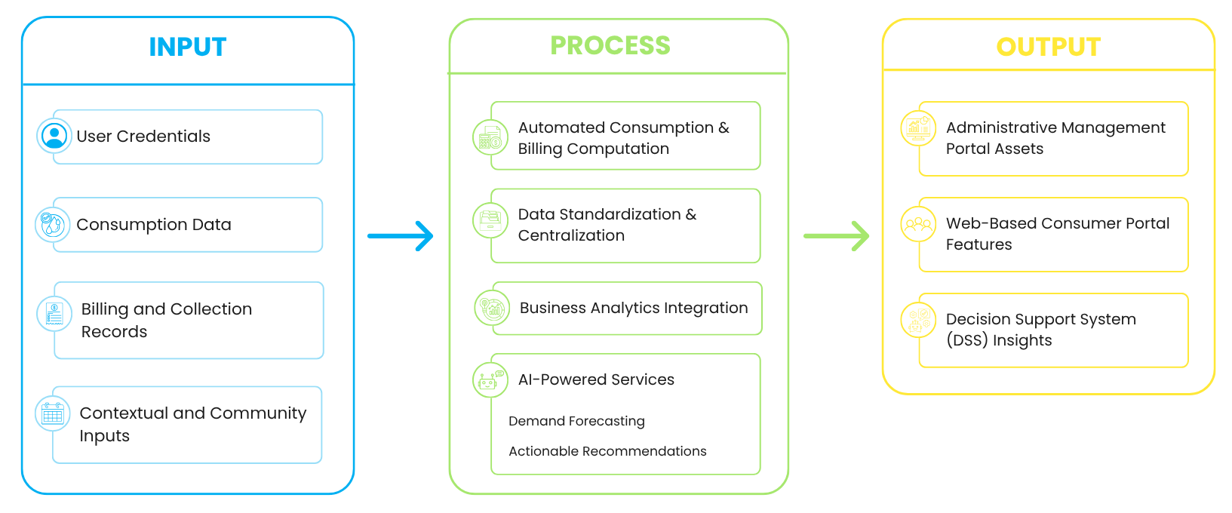

As shown in Figure 1, the Input phase serves as the critical foundation of the framework by centralizing raw data gathered directly from the water distribution infrastructure to establish a comprehensive dataset for processing and analysis. This phase incorporates User Credentials to ensure secure, role-based system access across all stakeholder profiles. It further includes sequential field meter readings encoded by the meter reader, manual billing entries, and payment transactions. Additionally, the framework ingests specific administrative inputs, such as scheduled barangay community events, localized public festivities, operational maintenance periods, and water service interruption dates, ensuring that all subsequent system operations are grounded in the community's actual operational cycles.
This foundational data then flows into the Process phase, which acts as the engine of transformation by converting raw inputs into meaningful, structured information. A pivotal component of this stage is the execution of the Automated Consumption & Billing Computation engine, where the platform automatically calculates volumetric water consumption and exact financial balances based on standardized water rates. Through Data Standardization & Centralization, the system organizes these records into a unified relational schema to eliminate the fragmentation, data inconsistencies, and mathematical inaccuracies associated with previous manual, handwritten logbooks. This structured dataset then moves into Business Analytics Integration, which dynamically aggregates and computes longitudinal records to build macro-level comparisons and consumer usage trends. Finally, the framework deploys its AI-Powered Services, running the historical baselines and context-tagged inputs through advanced analytical modules to execute predictive Demand Forecasting and generate context-aware Actionable Recommendations for local water system operations.
The Output phase is the final step where the system turns processed data into clear, actionable results that users can leverage to make data-driven decisions. Through the Web-Based Consumer Portal, residents receive automated account notifications, historical water consumptions, secure access to billing history logs, real-time balance tracking, and downloadable digital receipts. Concurrently, the Administrative Management Portal delivers high-level operational tools to barangay officials. Key outputs include interactive trend visualization dashboards highlighting monthly, yearly, and purok-by-purok usage patterns, alongside automated PDF financial summaries and broadcast management capabilities for dispatching water service announcements. Finally, the platform delivers intelligent demand forecasts for long-term resource planning and context-aware administrative recommendations. This final phase completes the IPO cycle by providing a proactive decision support mechanism that optimizes water distribution, reduces resource wastage, and promotes sustainable management practices across the entire local community.

- METHODOLOGY
This chapter discussed the design and methodology of the study. It presented the project concepts, development model, analysis of requirements, system design, development tools, testing plans, and deployment plans.
3.1 Research Design
This study will utilize the Agile Development Methodology in the design and development of the proposed web-based water distribution monitoring and decision support system for Sucol Water System. Agile is an iterative and flexible approach that emphasizes continuous development, collaboration, and user feedback. The development process follows a structured sequence of phases: Requirements Gathering, Design, Development, Testing, Deployment, and Evaluation.
Figure 2
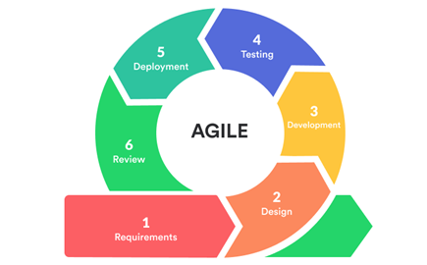
Agile Development Model
Source:https://ardas-it.com/what-is-the-right-development-methodology-agile-development-advantages-and-disadvantages
Figure 2 illustrates the Agile Development Model, which serves as the iterative framework for the system’s design and implementation.
In the Requirements Gathering Phase, the researchers will conduct interviews and observations with the assigned personnel from the Barangay Sucol to understand the current manual processes of consumption readings, and payment management. The collected data will be analyzed to identify system requirements, which will then be organized into prioritized features such as consumption data encoding, centralized record management, and report generation. This data flows directly into the next phase by defining the functional scope that the system must satisfy.
This requirement set then flows into the Design Phase, where the researchers develop the system architecture, database structure, and user interface. Wireframes and mock-ups will be created to illustrate how users will interact with the system, particularly in encoding and managing water-related data. The design will focus on simplicity, clarity, and usability to ensure that authorized personnel can easily adopt the system. These finalized designs then proceed into the Development Phase, where the system is built incrementally through iterative cycles.
In the Development Phase, the proposed system will be built based on the defined requirements and design. System features will be divided into smaller tasks and developed incrementally through iterative cycles. Core functionalities such as consumer record management, meter reading encoding, billing computation, payment recording, balance monitoring, and report generation will be implemented during this phase. A Progressive Web Application (PWA) architecture will be implemented across the entire system, providing an installable, cross-platform interface accessible to all user roles on both desktop and mobile devices. Leveraging integrated Service Workers and client-side caching, the platform will support robust offline functionality across its operational modules—enabling tasks such as field data encoding even in low- or zero-connectivity zones. All locally captured records will be securely cached and automatically synchronized with the central database as soon as network connectivity is re-established. Additionally, Decision Support System (DSS) features such as data visualization and trend analysis will be integrated, along with AI capabilities including demand forecasting and intelligent recommendation features that provide actionable insights for efficient water usage. Continuous testing and debugging will be conducted to ensure system accuracy, functionality, and reliability. The functional prototypes resulting from the build cycles then flow from the development environment into the Testing Phase.
In the Testing Phase, the developed system will be evaluated to ensure that all features function correctly and meet the intended requirements. Various testing methods will be applied to identify errors and verify system performance. Unlike traditional models, this study will emphasize active client involvement through bi-weekly consultations and Sprint Reviews. During these sessions, the users will be presented with functional prototypes to provide immediate feedback on the interface and logic. Identified issues will be documented and addressed to ensure system accuracy, reliability, and user satisfaction. Once validated through these sessions, the stable and verified system version flows into the Deployment Phase.
In the Deployment Phase, the finalized system will be made accessible through web browsers for authorized users, including the Barangay Officials, Meter Reader, and Consumers. Users will be oriented on the proper use of the system, including data encoding, monitoring, and report generation. This phase will ensure a smooth transition from manual recording to a centralized digital platform.
Finally, the project enters the Review Phase, where the live platform is assessed for its effectiveness in improving institutional data organization and monitoring efficiency. User feedback will be gathered to evaluate system performance and identify areas for further improvement. If the evaluation reveals areas for further improvement or unmet operational needs, the project team will loop back to the Design or Development phases for refinement. This iterative workflow ensures that development concludes with a functional, high-performance system that supports the long-term sustainability goals of the community while remaining adaptable to future enhancements.
3.2 Client Requirements Analysis
This section presents an analysis of the client’s current system, covering the client profile, existing setup, system requirements, and identified problems. The findings will serve as the basis for designing the proposed system.
3.2.1 Client Profile
The client of this study is the Sucol Water System, a community-managed water service operating under the Barangay of Sucol, Balayan, Batangas. The water system is responsible for providing water services to households within the barangay, including the monitoring of water consumption, recording of meter readings, billing computation, payment collection, and management of consumer records. These processes are handled by barangay officials and assigned personnel, including the meter reader who conducts monthly household visits to record water consumption and authorized staff responsible for billing computation, payment recording, and updating of consumer accounts. The consumers are the residents connected to the Sucol Water System who are responsible for paying their monthly water bills through the barangay outpost. The current management process of the Sucol Water System mainly relies on manual recording using logbooks and paper-based documents. Monthly meter readings, billing information, payment transactions, and consumer balances are manually recorded and computed by authorized personnel. Although this process allows the barangay to manage water service operations, it is time-consuming, labor-intensive, and prone to human error, especially when handling a large number of consumers.
3.2.2 Current System Analysis
The current water consumption management at Sucol Water System relies on a decentralized and manual workflow involving the Barangay Officials, Meter Reader, and Residents of Barangay Sucol.

Figure 3
Process Flow Diagram of the Sucol Water System
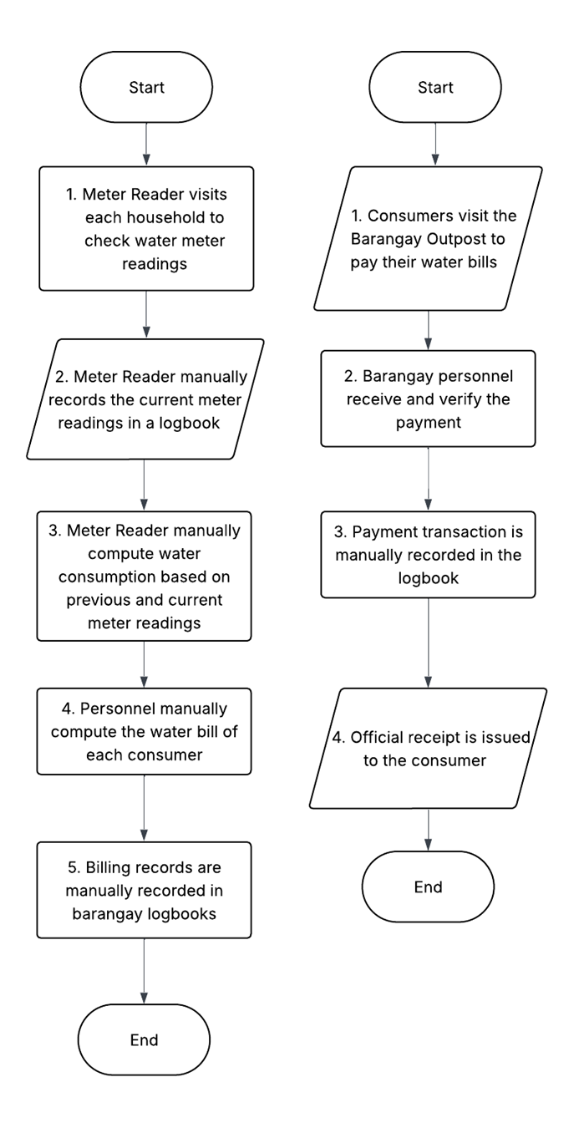
Figure 3 illustrates the current manual workflows for water consumption monitoring, billing computation, and payment processing at the Barangay level. These diagrams depict the fragmented and heavily labor-intensive nature of the existing system, where records are kept physically and transitions between steps rely entirely on manual interventions.
The first flow describes the water consumption and billing process, which begins with a Meter Reader visiting each household to physically check water meter readings. The current readings are then manually recorded in a physical logbook. Following this collection phase, the Meter Reader manually computes the water consumption by comparing previous and current meter readings. The workflow then transitions to administrative personnel, who manually calculate the final water bill for each consumer. This process concludes with the billing records being manually written down in the primary barangay logbooks, a method highly susceptible to data entry errors, omissions, and physical damage.
Parallel to this, the second flow focuses on the revenue collection process, which is initiated by consumers visiting the Barangay Outpost in person to settle their water bills. Upon arrival, Barangay personnel receive and verify the payment against existing records. Once verified, the payment transaction is manually recorded into another physical logbook to update the ledger. This process concludes with an official receipt being manually issued and handed over to the consumer as proof of transaction.
In conclusion, these diagrams highlight the significant operational inefficiencies that define the local community's current water management infrastructure. The heavy reliance on physical home visits, manual mathematical computations, in-person payment collections, and fragmented paper record-keeping across multiple logbooks demonstrates a clear lack of a centralized, automated digital platform, which ultimately increases administrative burdens and the risk of human error.

3.2.3 Problem Identification
Based on the analysis of the current system and the interviews conducted with authorized personnel of the Barangay Sucol Water System, the existing water management process faces several operational challenges caused by manual procedures, technological limitations, and inefficient communication practices, resulting in delayed and unreliable service management. One of the primary concerns is the difficulty in preparing monthly income, and revenue reports because records are still handwritten. The absence of automated record-keeping and centralized data management increases the risk of writing errors, data inconsistencies, and time-consuming documentation processes, making report generation inefficient and prone to inaccuracies.
Another major issue is the improper handling and storage of customer receipts. Since receipts are manually written and physically distributed, customers often misplace them, while some records contain inaccurate or incomplete information. This inability to maintain organized and secure records makes payments difficult to validate and history of customer transactions hard to keep track of. Further, the process does not offer a dependable digital back-up system, which may lead to the loss of, or harm to, records over time.
The water system also experiences communication challenges regarding water service interruptions and announcements. This results in inconvenience, confusion, and dissatisfaction among residents who rely on timely information regarding availability and maintenance schedules, which causes inconvenience, confusion and dissatisfaction. Traditional and informal communication routes are vital and significantly restrict the effectiveness and effectiveness of public announcements.
Furthermore, the current system lacks analytics and automated monitoring capabilities that could support efficient operational planning and decision-making. Manual data processing makes it difficult for employees to gain insight into water service patterns, money-making or customer issues. Currently, the organization does not have a centralized digital record or automation solutions for reporting, which hinder the ability to make proactive, data-informed improvements. Therefore, it is still reliant on a practice of reactive management of the Barangay Sucol Water System, which in turn provides less efficient services and service quality for the residents.
3.2.4 Functional Requirements
The following section will illustrate how the system will be utilized by the various stakeholders—including Barangay Officials, Meter Reader, and Barangay Consumers as well as the specific characteristics and operational capabilities each role will perform.
- Barangay Official
  - The system shall validate the login credentials such as email address and password to access the system.
  - The system shall provide barangay officials with account management capabilities to oversee both consumers and meter readers, including the ability to register new user accounts, assign operational roles, and update account statuses.
  - The Barangay Official shall input barangay events (e.g., fiesta, San Juan Festival) using a calendar-like interface to provide baseline data for AI analysis
  - The system shall display interactive trend dashboards showing yearly and monthly water consumption breakdowns.
  - The system shall allow the barangay official to export reports in common formats such as PDF.
  - The system shall maintain a history of all past billing and payment transactions for transparency and auditing purposes. .
  - The system shall allow the administrator to create and send announcements to consumers regarding water interruptions or maintenance activities.
  - The system shall provide demand forecasts that project future water usage based on historical data and contextual barangay events.
  - The system shall utilize AI to analyze historical consumption patterns and contextual events to generate data-driven recommendations for water management, resource optimization, and operational adjustments.
- Meter Reader
  - The system shall validate the login credentials such as email address and password to access the system.
  - The system shall allow the meter reader to record water readings directly via the mobile-responsive Progressive Web Application (PWA).
  - The system shall automatically calculate each customer’s billing based on the recorded consumption and the set water rates.

- Barangay Consumers
  - The system shall validate the login credentials such as email and password to access the system.
  - The system shall allow consumers to view their historical water consumption trends, including overall monthly and yearly usage patterns, via both the web platform and the installable Progressive Web Application (PWA) across desktop and mobile devices.
  - The system shall automatically update the customer’s billing and payment records once the payment is completed.
  - The system shall send an E-receipt to the customer’s portal.
  - The system shall allow the consumer to receive updates and notification alerts from the barangay officials.

Use Case Diagram
The Use Case Diagram of the WaterWise System illustrates how the different stakeholders interact with the proposed system.

Figure 4
Use Case Diagram of the WaterWise System
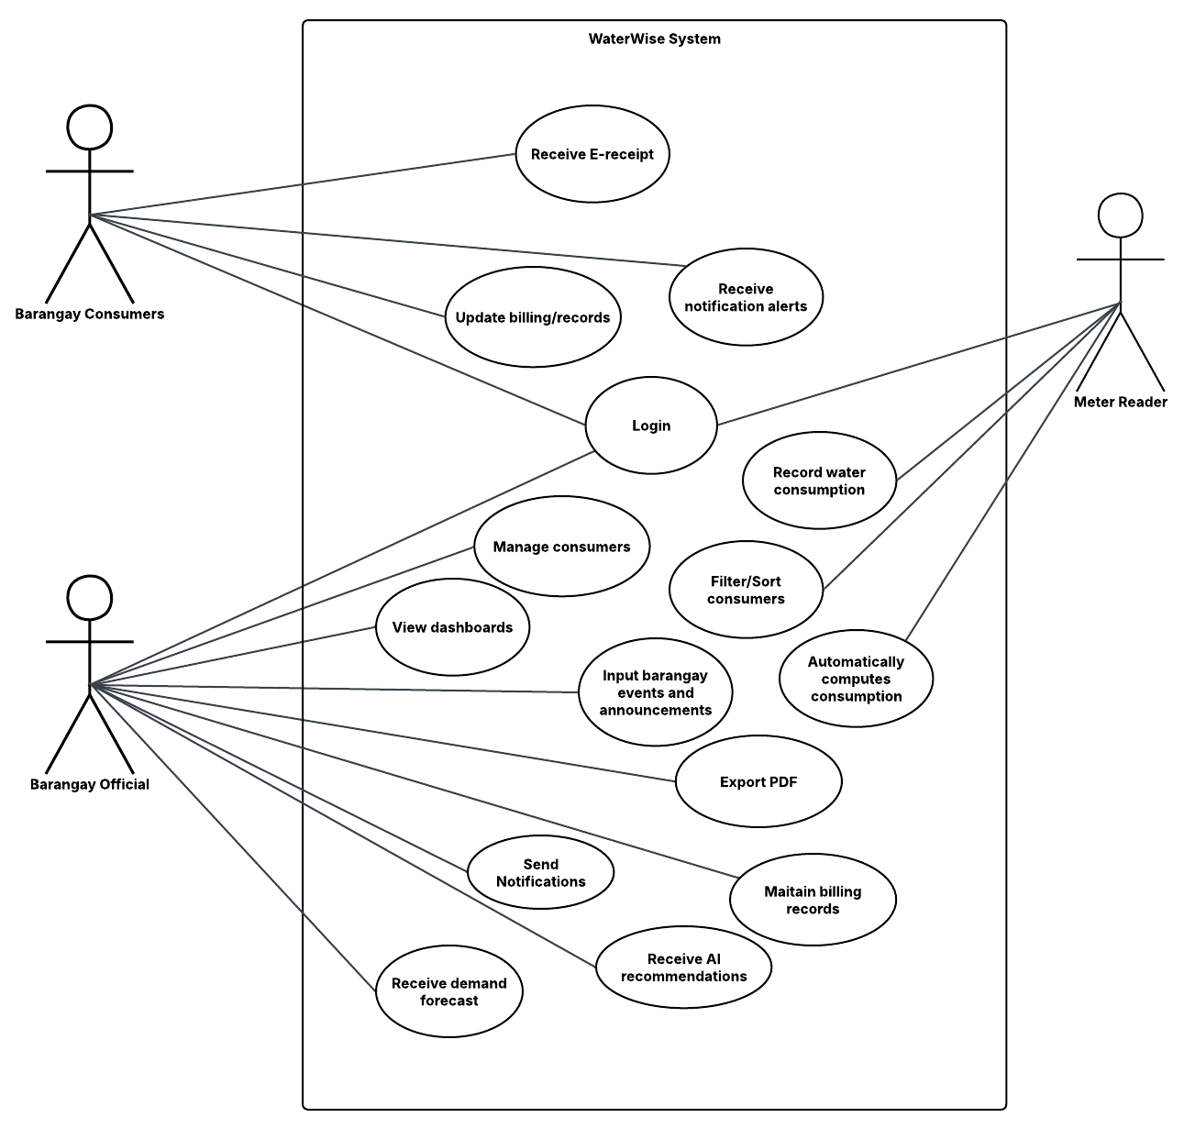
Figure 4 illustrates the use case diagram of the WaterWise System, which will be designed to support water consumption monitoring, billing management, consumer services, and advanced analytical decision support within the barangay water distribution process. The system will involve three primary actors: Barangay Consumers, Meter Readers, and Barangay Officials, each assigned with specific functions and responsibilities within the platform. Barangay Consumers will be able to log into the system, view historical water consumption trends, receive electronic receipts (E-receipts), obtain notification alerts such as billing statements, payment confirmations, outstanding balances, and administrative announcements, and update account records, allowing them to access water-related information conveniently and transparently.
The Meter Reader will serve as the operational source of consumption data by recording and submitting water consumption readings sequentially into the system. Once encoded, the platform will automatically compute water consumption and billing information, reducing manual computation errors while improving billing accuracy and processing efficiency. On the administrative side, Barangay Officials will be responsible for managing consumers, maintaining billing records, filtering and sorting consumer data, inputting barangay events and announcements, creating and broadcasting announcements, exporting PDF reports, sending notifications, and monitoring dashboards. The officials will also receive intelligent demand forecasts and smart administrative recommendations, enabling them to make data-driven decisions and improve water resource management.
Overall, the WaterWise System will integrate consumer services, operational monitoring, automated consumption and billing computations, administrative management, and intelligent analytics into a centralized platform. Through these integrated functionalities, the system will enhance operational efficiency, transparency, responsiveness, and decision-making in managing the Sucol Water System.
3.2.5 Non-Functional Requirements
The following section will outline the non-functional requirements of the proposed system, defining the essential quality standards and operational constraints that ensure the platform is performant, secure, reliable, and usable.
- Performance:
  - The system shall instantly process individual consumption and billing calculations within 2.0 seconds of a meter reader saving an entry.
  - The interactive data visualization dashboards shall aggregate longitudinal data and fully render charts (monthly, yearly, and purok-by-purok comparisons) within 3.0 seconds of an administrator loading the page.
  - The system shall compile and generate exportable PDF financial and consumption reports from the centralized dashboard within 5.0 seconds of the request.
- Security
  - The system shall strictly enforce Role-Based Access Control (RBAC), ensuring that data modification tools (e.g., billing adjustments, announcement broadcasting) are accessible only to authenticated administrators, while limiting meter readers to data entry.
  - All user passwords and session credentials shall be securely encrypted using industry-standard hashing mechanisms before being stored in the database.
  - Authenticated sessions shall automatically expire after 15 minutes of inactivity to prevent unauthorized terminal access.
  - Personal consumer records, account profiles, and transaction histories shall be protected against unauthorized access using secure web protocols (HTTPS).
- Reliability:
  - In the event of a network interruption or session timeout, the system shall recover the last unsubmitted draft within 5 seconds of reconnection.
  - The platform shall maintain an operational uptime of 99.5% during critical end-of-month billing, payment logging, and report generation periods.
  - The centralized repository shall guarantee data synchronization consistency, ensuring that manually logged payments and updated consumer profiles reflect across the administrative and consumer portals instantaneously without data loss.
  - The automated consumption logic shall maintain 100% mathematical accuracy when aggregating consumption and billing computations to eliminate the errors associated with previous manual computation methods.
  - The system shall support automated periodic backups of consumer records, billing computations, and transaction logs to prevent data loss in the case of server failures.
- Usability:
  - The administrative and consumer user interfaces shall be clear, clean, and intuitive, requiring no extensive technical training for water system personnel or local residents to perform basic tasks.
  - The web interface shall follow clean design principles (e.g., high-contrast text and logical grouping of data) to ensure that dashboards are interpreted correctly within 5 seconds of viewing.
  - The Web-Based Consumer Portal shall be optimized for seamless viewing across multiple devices, including desktop monitors, tablets, and smartphones (9:16 and flexible viewports) so residents can easily track balances and view announcements.
  - The system shall display helpful, clear, and non-technical error messages when validation fails (e.g., indicating missing fields or invalid characters in manual logs) rather than throwing breaking database errors.
  - Administrative announcements regarding water interruptions or maintenance activities shall be prominently highlighted and easily accessible upon consumer login.
3.2.6 System Context
This subsection delineates the data flows and system boundaries connecting the platform to external operational entities within the barangay. It shows the flow of data between the system and the various stakeholders in the water distribution operations, billing management, consumer services, and administrative decision-making within the barangay. The figure demonstrates the overall data flow architecture of the proposed system, highlighting the interaction between the Barangay Consumers, Meter Reader, and Barangay Officials through a unified web-based environment.
Figure 5
Context Diagram of the WaterWise System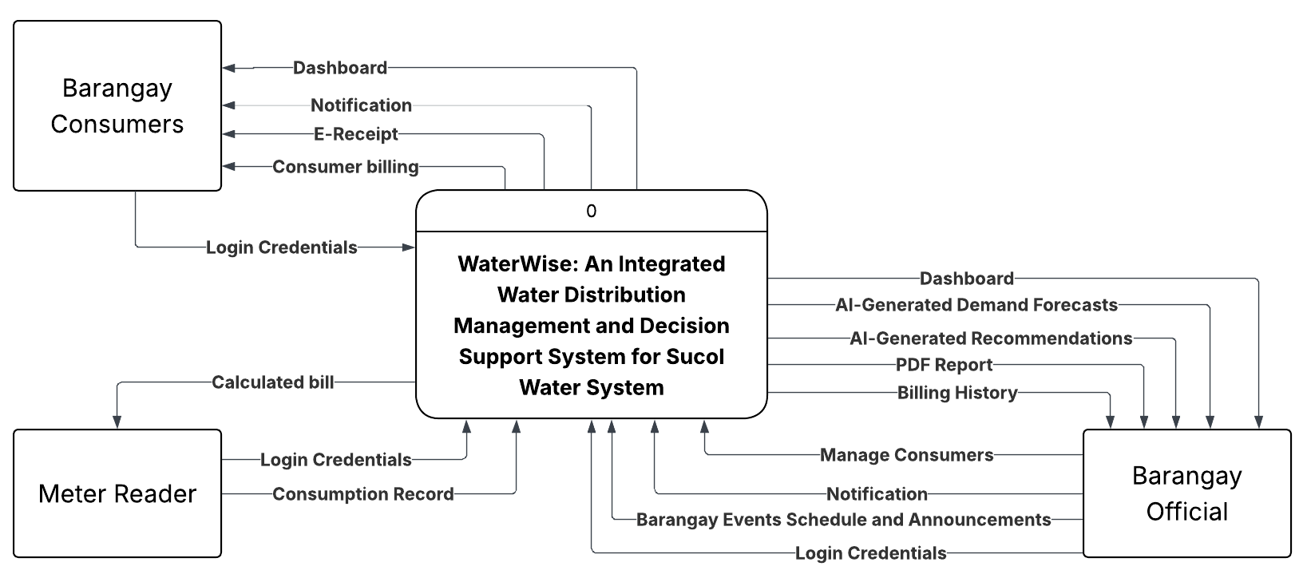
Figure 5 presents the WaterWise: An Integrated Water Distribution Management and Decision Support System for the Sucol Water System as a centralized and intelligent platform that facilitates data exchange between various barangay personnels and consumers. The operational process will begin with the submission of login credentials by all external entities to establish secure, authenticated, and role-based access to the system. This security mechanism will ensure that users can only access functionalities and information relevant to their designated responsibilities. Once authenticated, each stakeholder will interact with the system according to their operational role within the water distribution process.
For the Barangay Consumers, the system will serve as an accessible service portal where users can conveniently monitor their water-related transactions and records. Through the dashboard interface, consumers will be able to monitor historical water consumption trends, receive real-time notifications, access electronic receipts (E-Receipts), and review their corresponding consumer billing information. This integration will significantly enhance transparency, improve customer engagement, and minimize the inefficiencies commonly associated with manual billing dissemination and paper-based recordkeeping. Furthermore, the availability of digital transaction records will promote accountability and allow consumers to monitor their water consumption and financial obligations more effectively.
The Meter Reader will function as the primary source of operational consumption data within the system. After conducting field meter inspections, the meter reader will submit consumption records sequentially into the centralized platform. These encoded readings will become the basis for the system’s automated consumption and billing computation process. Through system-generated calculations, WaterWise will reduce the likelihood of human error, accelerate billing procedures, and improve the overall accuracy and consistency of consumer account processing. The automated calculation mechanism will also strengthen operational efficiency by eliminating repetitive manual computations traditionally performed in conventional water billing systems.
On the administrative level, the Barangay Officials will utilize the system as a comprehensive monitoring and decision-support platform. The system will enable officials to manage consumer accounts, review billing history, create and broadcast announcements, and input barangay event schedules within a centralized environment. More importantly, the dashboard will provide advanced analytical features such as intelligent demand forecasts, smart administrative recommendations, and downloadable PDF reports. These intelligent capabilities will elevate the proposed system beyond a conventional management platform by incorporating predictive and analytical functionalities that support evidence-based governance and strategic planning. Through demand forecasting, officials will be able to anticipate fluctuations in water consumption based on longitudinal data, optimize water distribution strategies, and prepare for potential supply challenges. Simultaneously, the smart administrative recommendations will assist administrators in identifying operational improvements, enhancing resource allocation, and supporting sustainable water management practices by actively factoring historical community events and operational contexts into its logic.
The integration of these functional components will demonstrate the system’s capacity to establish a synchronized and data-driven operational ecosystem for the Sucol Water System. By consolidating consumer services, billing automation, monitoring tools, and intelligent decision-support mechanisms into a single platform, WaterWise will promote operational efficiency, administrative transparency, and responsive public service delivery. Ultimately, the proposed system will strengthen the barangay’s ability to manage water distribution resources effectively while fostering accountability, accuracy, and long-term sustainability in local water service operations.
3.3 System Architecture
System Architecture Diagram
The System Architecture Diagram of WaterWise System illustrates the general design and communication between the key elements of the proposed smart water management system.
Figure 6
System Architecture of the WaterWise System
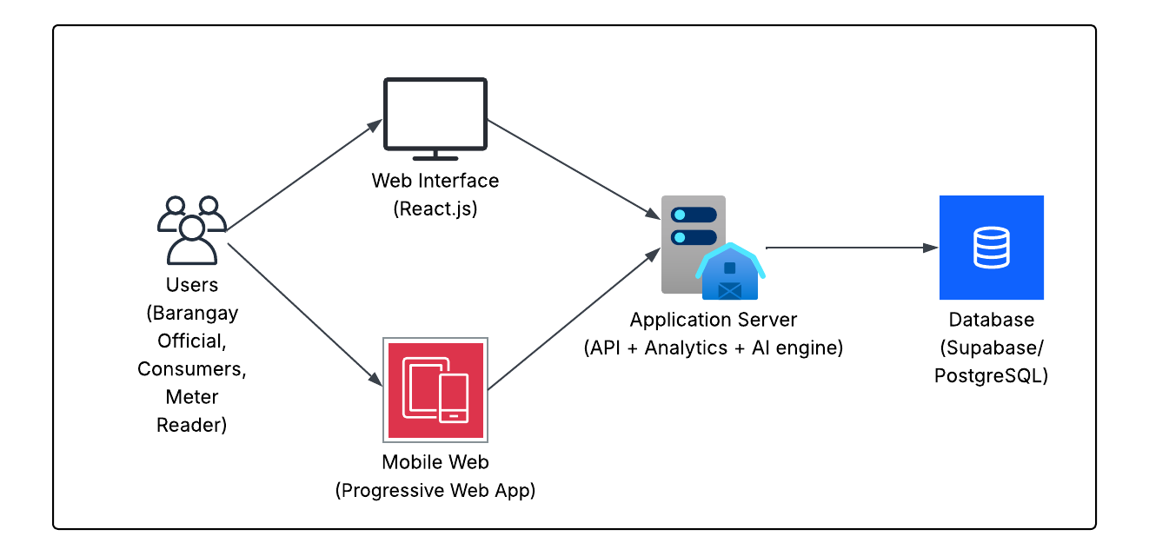
Figure 6 illustrates the architecture of the WaterWise: An Integrated Water Distribution Management and Decision Support System for the Sucol Water System. The system will support Barangay Officials, Consumers, and Meter Readers through a React.js web interface and a mobile-responsive Progressive Web Application (PWA), ensuring accessible and real-time interaction across devices. Both platforms will connect to the Application Server, which will function as the central processing unit responsible for API services, analytics, system-generated smart functionalities, automated consumption and billing computations, PDF report generation, and overall decision-support operations.
The system will also integrate an advanced analytical services engine that will analyze water consumption data and event-tagged contextual contents to generate intelligent demand forecasts and provide smart administrative recommendations for efficient water distribution management. Additionally, Supabase/PostgreSQL will serve as the centralized database infrastructure where user accounts, billing records, consumption data, broadcast logs, generated reports, and analytical outputs will be securely stored and processed. Overall, the architecture will demonstrate a scalable and intelligent framework that enhances operational efficiency, transparency, responsiveness, and sustainability in managing the Sucol Water System.
Data Flow Diagram
The Level 1 Data Flow Diagram (DFD) illustrates a detailed decomposition of the WaterWise system, illustrating the specific internal processes, data stores, and information pathways that facilitate community water management. Unlike a context diagram, this Level 1 view breaks the system down into eight distinct functional processes—ranging from data collection and management to advanced AI services.

Figure 7
Data Flow Diagram of the WaterWise System
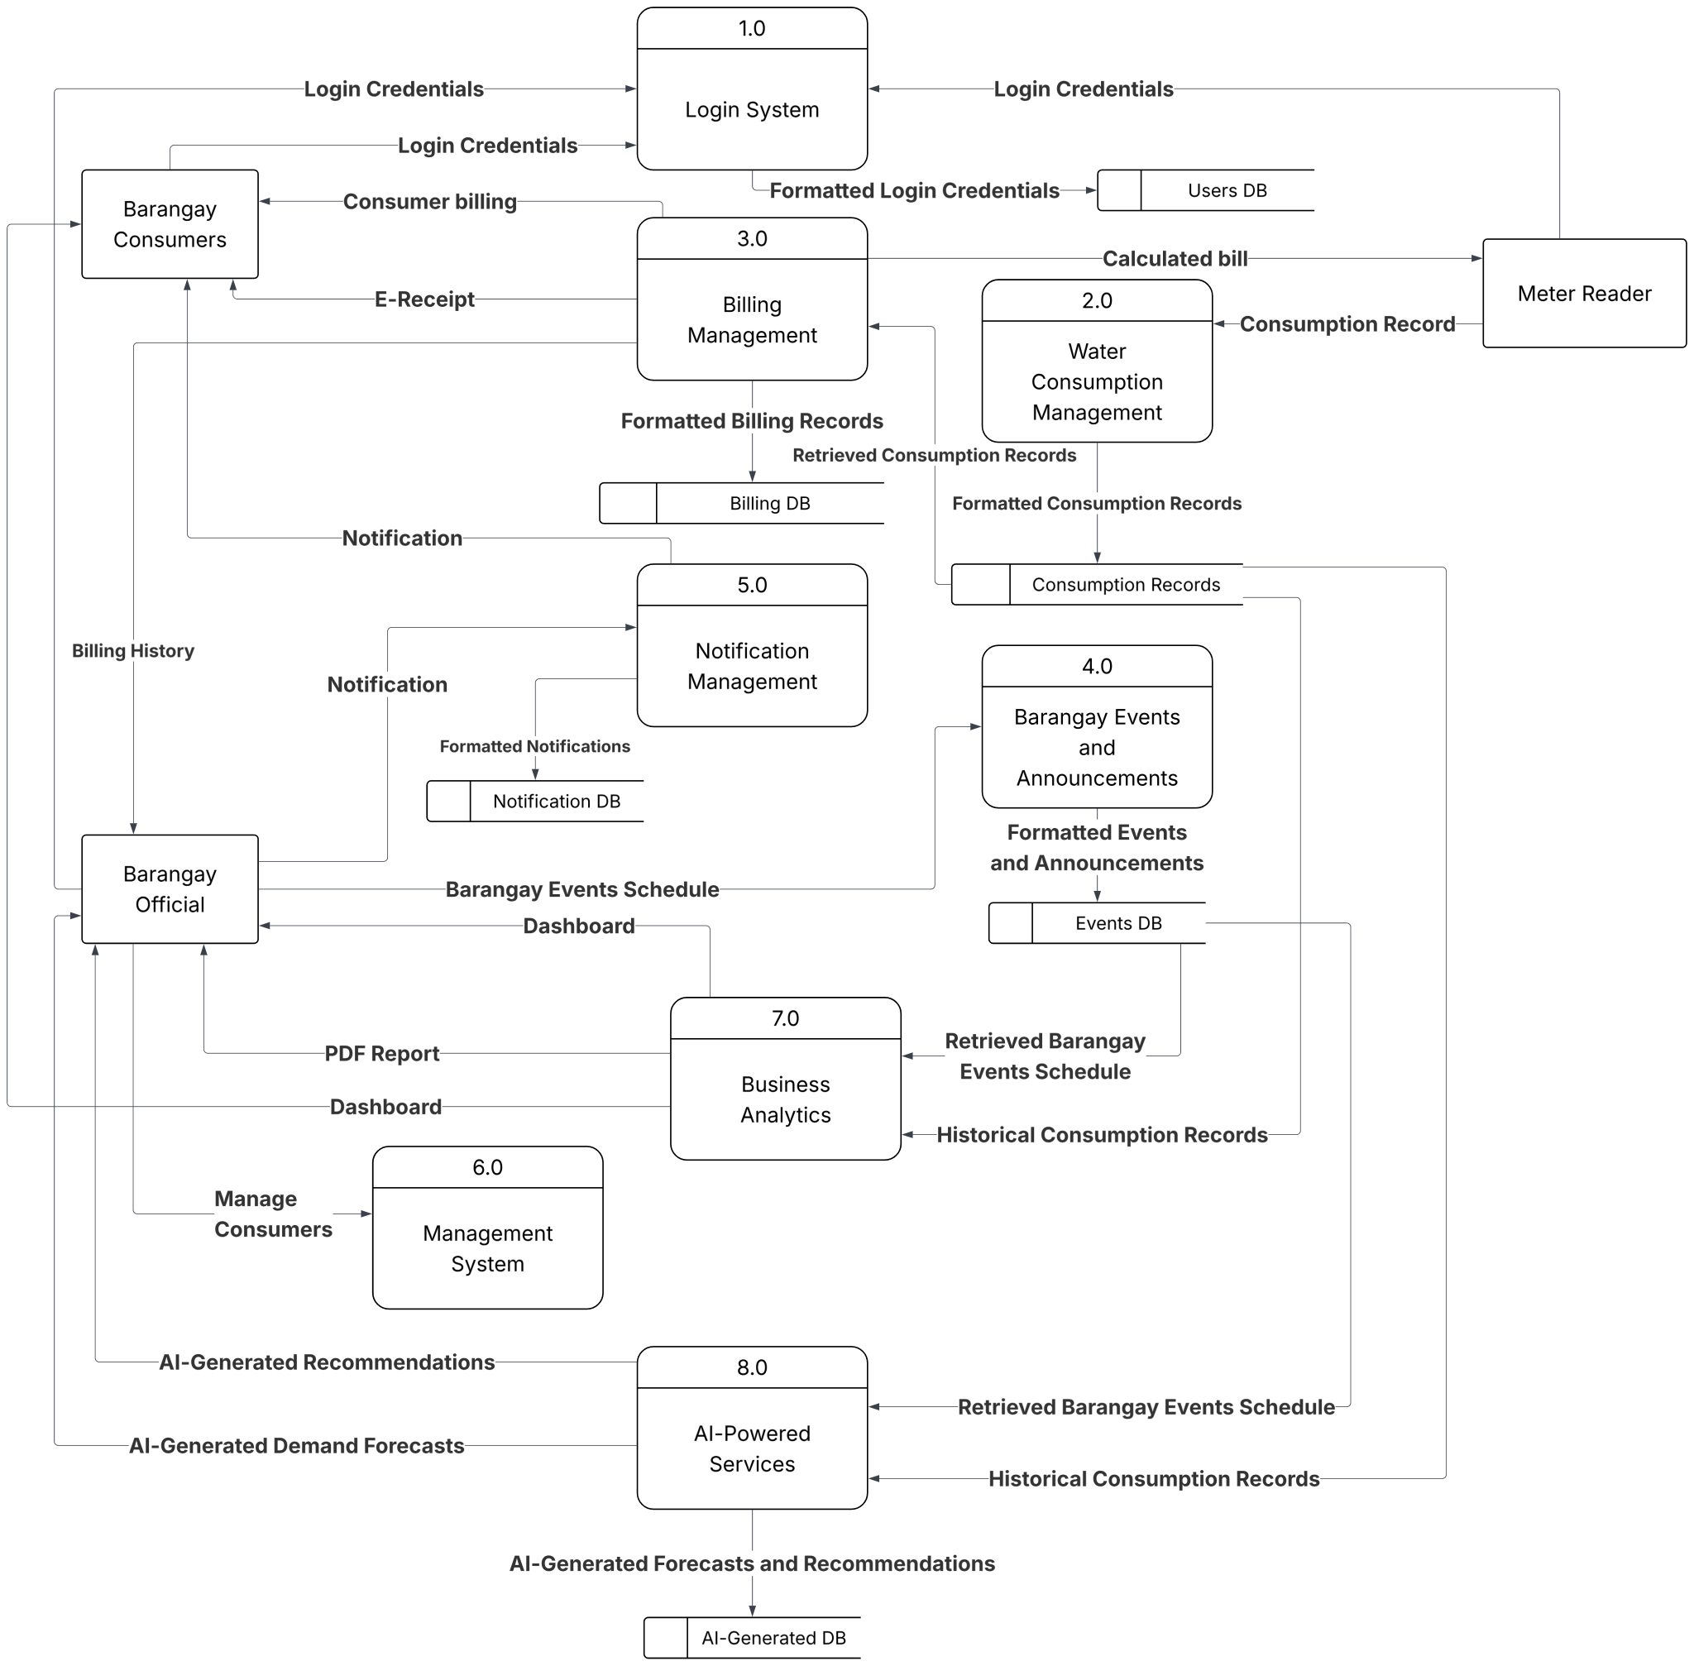
Figure 7 illustrates how the data related to water consumption, manual billing computations, manual payment collections, barangay community events, broadcast announcements, and user credentials are handled and stored in the system to facilitate monitoring, advanced analytics, and decision-making processes.
The operational lifecycle will initiate with Process 1.0 (Login System), which will capture and validate the incoming login credentials from Barangay Consumers, Barangay Officials, and Meter Readers. Upon authentication, this process will transmit formatted login credentials to the Users DB data store to confirm role-based access tokens, thereby granting secure, customized portal entry. For field operations, the Meter Reader will interact directly with Process 2.0 (Water Consumption Management) by encoding physical consumption records. This process will immediately structure the input into formatted consumption records, saving them securely within the Consumption Records data store. Simultaneously, Process 3.0 will transmit the calculated bill information to Process 2.0 (Billing Management) to initiate the automated financial processing cycle.
Process 2.0 (Billing Management) will read retrieved consumption records from the database and handle all financial tracking operations. It will push formatted billing records into the Billing DB and dispatch real-time data outputs directly to the consumer, providing Barangay Consumers with electronic receipts (E-Receipts) and clear consumer billing views. To keep the community informed, Process 4.0 (Barangay Events and Announcements) will allow Barangay Officials to input specific barangay events schedules and operational announcements. This process will convert the administrative inputs into formatted events and announcements before saving them securely inside the Events DB.
The system will manage communication dynamics through Process 5.0 (Notification Management), which will act as a centralized alert engine. This module will ingest data streams from Process 3.0 and Process 4.0, deposit formatted notifications into the Notification DB, and broadcast real-time notification dispatches—such as billing statements, payment confirmations, outstanding balances, and administrative alerts—directly onto the portals of the Barangay Consumers. For system administration, Barangay Officials will utilize Process 6.0 (Management System) to handle administrative oversight, passing data down the data line to securely manage consumer accounts and filter baseline records.
The advanced decision-support capabilities of the platform will be driven by the parallel execution of the analytics and smart services modules. Process 7.0 (Business Analytics) will dynamically aggregate historical consumption records from the Consumption Records store and retrieved barangay events schedules from the Events DB. This process will systematically compute the data to generate interactive data visualization dashboards and compile downloadable PDF reports for Barangay Officials, giving administrators clear operational overviews of consumer trends and monthly, yearly, and purok-by-purok usage patterns. Concurrently, Process 8.0 (AI-Powered Services) will fetch longitudinal historical consumption records and contextual events data to power its predictive architecture. This smart processing engine will generate intelligent demand forecasts and smart administrative recommendations, routing the analytical outputs to the AI-Generated DB data store while transmitting real-time predictive insights back to the Barangay Officials' centralized dashboard terminal.
3.4 AI Integration Design
To address the operational inefficiencies of the Sucol Water System, artificial intelligence is integrated into the centralized web-based platform to transition operations from reactive manual tracking to proactive, data-driven management. This section outlines the specific AI tools utilized, their core purposes, and the methods used to embed these intelligent capabilities into the system.
Demand Forecasting Engine
The demand forecasting module will utilize the Gemini API to analyze historical records of monthly water consumption stored within the centralized database. By processing longitudinal usage data, the AI will produce estimated water usage patterns and future demand projections to assist barangay personnels in resource planning and infrastructure scaling. This selection is supported by the model's strong coherence, which will allow it to integrate diverse datasets to maintain a logical flow in its analytical outputs (Kalluri & Kokala, 2024). To integrate this feature, the system will automatically extract historical data and contextual event tags from the database, feed it into the Gemini API, and render the resulting predictive trends into visual charts within the administrator’s dashboard.
Decision Support Recommendation Engine
The automated recommendation feature will synthesize insights from the forecasting to provide data-driven administrative guidance. The engine will generate actionable suggestions regarding water conservation efforts and monitoring priorities based on water-related data stored in the database. To ensure institutional safety and reliability, the engine will utilize Gemini AI’s robust ethical framework to ensure that all generated administrative recommendations adhere to responsible AI principles, ensuring that community reporting remains transparent, unbiased, and operationally reliable (Kalluri & Kokala, 2024). This feature will be integrated by systematically processing consolidated system trends and event-tagged contexts through the Gemini API's reasoning capabilities upon data entry, which then outputs automated action items directly onto the barangay management portal.
3.5 Development Tools and Technologies
This section outlines the programming languages, frameworks, and platforms that will be utilized to develop the WaterWise. The selection of each tool is guided by a systematic review of contemporary research in related technologies, ensuring that each component aligns with the specific functional demands of the project and integrates seamlessly within the overall technical architecture.
Programming Languages
JavaScript will serve as the primary programming language for the development of the system’s frontend, backend, and PWA components. This approach serves as a suitable foundation for WaterWise, as its flexible nature facilitates the rapid prototyping needed to adapt to the community's evolving operational requirements. Technically, JavaScript excels in operational performance, specifically demonstrating superior efficiency in initial data rendering and the creation of large row sets upon page load, which is critical for the system's real-time monitoring dashboards (Bielak et al., 2022).
Frameworks
React will be utilized to provide a lightweight and responsive mobile-first experience. The framework's specialized focus on the user interface layer and its ability to track component dependencies will ensure that Barangay personnel receive dynamic consumption alerts and validation messages instantly without requiring a full page refresh (Bielak et al., 2022). Furthermore, the modular nature of React components will enable the researchers to enforce secure data silos for the users, ensuring that restricted modules remain performant and isolated from unauthorized access. Ultimately, the combination of optimized Document Object Model (DOM) functionality and robust community support will make React the most suitable choice for meeting the specific operational and technical requirements of the proposed institutional monitoring platform.
Tailwind CSS will be utilized to directly support the objective of providing a unique and adaptive monitoring experience for stakeholders. The system will employ a utility-first approach to create high-contrast visuals and custom dashboard aesthetics that establish a unique brand identity for the community, effectively avoiding the standardized appearance typically associated with traditional frameworks. Tailwind CSS is the most suitable technology for the user interface as its utility-first approach allows for the creation of high-contrast visuals and custom dashboard aesthetics that establish a unique brand identity for the community (Santoso, 2025).
Express.js will be utilized as the primary backend technology, particularly because the project employs JavaScript for its dynamic and flexible properties. This selection will be appropriate as Express.js provides the necessary flexibility to develop the system’s core features without the heavy boilerplate and architectural constraints of opinionated frameworks. Specifically, the adaptable nature of Express.js will facilitate rapid development cycles while ensuring that the team can maintain a custom architecture tailored specifically to the community's utility monitoring requirements (Munirov, 2025). Furthermore, its efficiency in managing large-scale web services will ensure that the system remains performant for institutional users during concurrent data handling.
Frontend Technologies
To support mobile accessibility for the users, the system will implement a Progressive Web Application (PWA) built with React. This technology will allow users to install the application directly from a browser and utilize smartphone features while providing a native-like experience with significantly smaller installation sizes compared to traditional mobile apps. This technology ensures Offline Operational Reliability, as Service Workers allow the application to remain functional even in areas with varying connectivity across different puroks within the barangay. A PWA provides the necessary balance of cost-efficiency, offline support, and accessibility, reducing long-term maintenance costs by up to 70% while enabling personnel to utilize smartphone camera features for capturing submeter images (Bhalla et al., 2026).
Backend Technologies
Node.js will be utilized as the primary runtime environment. Node.js provides the high-speed concurrent processing necessary to manage a high volume of simultaneous data entries and administrative queries, handling up to 30,000 concurrent connections more efficiently than alternative environments (Mohd et al., 2022). While alternative frameworks offer complex data binding, the project will prioritize the raw server performance and asynchronous architecture of Node.js to ensure that administrative dashboards remain functional and highly performant under institutional demand. This configuration will ultimately support a stable and scalable infrastructure capable of processing real-time utility data and heavy API traffic without performance degradation.
Database
To manage the large-scale tabular data of the WaterWise system, PostgreSQL will be utilized as the relational database management system within the Supabase environment. This technology is the most suitable for managing institutional utility records due to its superior handling of low data latency and robust concurrent processing, ensuring that consumption trends are processed within target response times (Salunke & Ouda, 2024). PostgreSQL’s efficient query execution will allow the system to maintain high transaction throughput without blocking concurrent users, which is essential for the high-speed interactivity required by administrative dashboards and the reliable data encoding performed by the Meter Reader and Barangay personnel. Ultimately, its ability to process millions of records while supporting complex analytical queries makes it the technically sound choice for the operational requirements of water distribution monitoring and demand forecasting.
Supabase will serve as the backend-as-a-service (BaaS) provider, utilizing a PostgreSQL relational database to manage complex data relationships. Supabase's relational architecture is technically sound for performing the complex analytical queries required for predictive water demand analytics (Amanuel, 2022). The platform's relational architecture ensures high-speed data retrieval and high throughput, which is essential for generating consumption trends through complex joins across the dataset. Furthermore, the scalable API generation feature of Supabase will automatically provide RESTful APIs directly from the database schema, facilitating near-instantaneous interactivity for the administrative dashboards.
APIs and AI Tools
To implement AI-based analytics, the Google Gemini AI API will be integrated to provide consumption predictions, and smart recommendations. Gemini AI demonstrates superior resource efficiency and scalability under varying computational loads, ensuring that the system remains responsive and cost-effective during the processing of monthly submeter readings while adhering to responsible AI principles (Kalluri & Kokala, 2024).
The system will utilize REST APIs as the primary architectural style to facilitate seamless communication between the frontend interface and the backend services. This technology is essential for the system's mission-critical need for high-speed data retrieval and high throughput to support near-instantaneous visualizations (Lawi et al., 2021). By employing standard HTTP methods, the REST API ensures that data regarding submeter readings and consumption alerts are transmitted efficiently, allowing institutional users to access real-time utility information without latency. This selection directly supports the system’s requirement for a responsive and scalable infrastructure, providing the necessary connectivity to integrate various administrative modules into a unified decision-support platform.
Deployment and Hosting
Vercel will be utilized as the primary deployment and hosting platform for the WaterWise system. This selection is justified by the requirement for high-speed interactivity, as Vercel’s focus on edge functions ensures that content is delivered from servers geographically closer to users, effectively minimizing data latency for administrative dashboards (Kniazev, 2023). Furthermore, given that the platform utilizes modern web frameworks, Vercel provides a technically sound environment that offers specialized optimizations for performance and asset delivery.
Version Control and Collaboration
Git and GitHub will be utilized for version control and collaborative development. The integration of GitHub Issues and Project Boards is highly appropriate for coordinating multifaceted tasks and preserving a permanent, versioned record of the system's decision-support logic (Chen et al., 2025). Git version control system will preserve a permanent, versioned record of its decision-support logic, ensuring that the platform remains maintainable and transparent even after the initial implementation phase. This structured collaboration environment will ultimately provide the institutional-grade oversight necessary to manage the system's complex technical requirements and evolving operational needs.
3.6 Implementation Procedure
The implementation of WaterWise will follow the Agile Development Methodology, utilizing an iterative approach that prioritizes technical flexibility and continuous alignment with the community’s operational needs. The development process will be executed across six sequential yet overlapping phases: Requirements Gathering, Design, Development, Testing, Deployment, and Review.

Phase 1: Requirements Gathering Phase
The procedure will begin with a deep-dive analysis of the community's current infrastructure. The researchers will conduct structured interviews and field observations with the barangay personnels of Barangay Sucol to map the existing manual workflow for recording submeter readings and laboratory results. The primary output of this phase is a Prioritized Product Backlog, which defines the functional scope the system must satisfy.
Phase 2: Design Phase
The requirement set will then flow into the Design Phase, where the technical blueprint of the system will be established. The researchers will develop the System Architecture and a PostgreSQL database schema via Supabase. During this stage, UI/UX wireframes and high-fidelity mock-ups will be finalized to illustrate the user journey. These designs will focus on intuitive navigation to ensure that the users can navigate the platform with minimal training. The finalized design assets will serve as the visual and structural guide for the subsequent build cycles.
Phase 3: Development Phase
The Development Phase will be the most intensive and hands-on part of the project, organized into three targeted cycles or "sprints." The research team will build the system using Node.js and React, working on both the visual interface and the background database at the same time to ensure everything fits together perfectly. Each sprint will focus on a specific part of the system and will be checked by barangay staff to make sure it meets their needs before the team moves forward.
Sprint 1 will focus on core project setup, secure user access, and foundational administration tools. During this phase, the researchers will configure the main database architecture and implement Role-Based Access Control (RBAC) to ensure that administrators and meter readers can log in securely with predefined permission boundaries. A major priority in this sprint will be the development of the Consumer Record and Meter Reading Management module to replace the current paper-based processes. The team will also build the automated backend engines for consumption and billing computation, ensuring that once meter readers encode utility data, water bills are instantly calculated and securely recorded without manual errors.
Sprint 2 will center on building the Web-Based Consumer Portal to provide transparency and digital access for local residents. The researchers will develop the secured portal framework, enabling consumers to set up account profiles and authenticate securely to access their personal utilities. During this sprint, the team will integrate features allowing residents to track their water consumption patterns, check outstanding account balances, and view detailed billing and payment histories alongside digital receipts. Finally, the team will implement the notifications system within this portal to alert consumers regarding account billing adjustments and administrative announcements.
Sprint 3 will focus on data visualization dashboards, community outreach tools, and formal reporting mechanisms. The researchers will develop the interactive data visualization dashboards designed to monitor historical water consumption trends, overall monthly and yearly comparisons, and localized purok-by-purok usage patterns. This ensures that the administration has a comprehensive, visual way to monitor baseline system metrics across different sectors of the community. Additionally, the team will implement the announcement creation and broadcast management framework, giving administrators the ability to compose and instantly send real-time alerts regarding upcoming water interruptions, pipeline maintenance activities, or administrative updates to the consumer portal. This sprint will conclude with the integration of the automated PDF report generation tool, merging collection tracking and consumption metrics directly within the administrative portal to provide officials with clean, exportable data summaries.
Sprint 4 will center on the integration of the system's intelligent decision support features and contextual tracking. During this final phase, the researchers will implement the administrative event-tagging framework, allowing barangay officials to log specific community activities and pipeline maintenance periods. The team will ensure that this event-tagged data directly feeds into the system's smart services, deploying the intelligent demand forecasting engine to project future water utility requirements and the smart administrative recommendations engine to provide actionable operational insights. By linking these features, the system will actively factor historical community events and operational contexts into its forecasts and recommendations to guide officials in resource scheduling and distribution adjustments.

Phase 4: Testing Phase
In the Testing Phase, the developed modules will undergo rigorous evaluation to ensure technical reliability and adherence to the specified requirements. Following the Agile principle of active client involvement, the research team will conduct bi-weekly consultations and Sprint Reviews with the stakeholders. During these sessions, stakeholders will interact with functional prototypes to evaluate the interface logic and provide immediate feedback. A primary focus will be the validation of the system's submeter reading entry and billing computations to ensure high accuracy in data verification and processing. Any identified bugs, usability issues, or technical discrepancies will be documented and resolved in the subsequent development cycle to ensure a stable and verified system prior to deployment.
Phase 5: Deployment Phase
Upon successful validation and stakeholder approval, the system will transition to the Deployment Phase, where the platform will be hosted on Vercel and made accessible to authorized barangay personnel. This phase facilitates the formal shift from manual, messaging-based recording to a centralized digital repository. The research team will conduct structured User Orientation Sessions to train personnel on the complete range of system features. These sessions will cover the end-to-end operational workflow, including secure login procedures, the use of the WaterWise for inputting meter readings, billing computation verification, and the encoding of consumer payment transactions. Barangay officials will also be oriented on how to receive and act upon the AI-generated demand forecasting, and recommendations, ensuring a seamless transition where the system provides direct, actionable information to the barangay administration without requiring complex data analysis.
Phase 6: Review and Evaluation Phase
The final stage of the procedure is the Review and Evaluation Phase, where the live platform will be assessed based on its operational performance and impact. The researchers will gather qualitative and quantitative feedback from users to determine if the system has effectively improved monitoring efficiency and reduced resource wastage. This evaluation will measure the system's success in meeting the community's long-term sustainability goals. Based on these findings, final refinements will be implemented to optimize the platform, ensuring that WaterWise remains a robust and flexible tool for future barangay infrastructure initiatives.
3.7 Testing and Evaluation
This section outlines the systematic procedures that will be used to test and evaluate WaterWise across all functional modules and user roles. To ensure the system's reliability and institutional value, testing will be organized into four distinct methods: functional testing, usability testing, user acceptance testing (UAT), and performance testing. Each method will target a specific dimension of system quality, with results analyzed against defined evaluation metrics. All evaluation activities will be conducted under the advisory supervision of the researcher adviser to ensure the system meets technical and community operational standards.

Functional Testing
Functional testing will be conducted to verify that every module operates strictly according to the specified system requirements. The primary focus will be on the Administrative Management Portal and Web-Based Consumer Portal, ensuring that Role-Based Access Control (RBAC) securely separates permissions for administrators, meter readers, and collectors. Testing will validate the accuracy of the automated consumption and billing computation, as well as the functionality of the consumer account profile creation. Additionally, the team will thoroughly test the Announcement Creation and Broadcast Management module to ensure administrators can successfully compose, schedule, and broadcast alerts regarding water interruptions, maintenance activities, and updates, verifying that these broadcasts are accurately distributed and instantly reflected on the consumer interface. Finally, the team will verify that the centralized dashboard correctly processes collection tracking and water consumption monitoring metrics to output accurate, automated PDF reports. Any identified failures will be documented and resolved within the same sprint cycle, ensuring a stable foundation before the system proceeds to usability and user acceptance testing.
Usability Testing
Usability testing aims to evaluate the user interface and user experience to ensure both barangay administrators and local consumers can navigate the platforms with minimal friction. This phase will involve observing user groups as they perform core operational tasks, such as logging meter readings, encoding events, viewing digital receipts, and tracking outstanding balances. Special attention will be given to observing administrators as they interact with the announcement creation panel to broadcast maintenance updates. The testing will evaluate how clearly information is displayed within the consumer notifications module for account billing and administrative updates. Furthermore, it will assess the layout clarity of the interactive data visualization dashboards, ensuring that administrators can easily interpret historical consumption trends, monthly and yearly overall comparisons, and localized purok-by-purok usage patterns without operational confusion.
User Acceptance Testing (UAT)
User Acceptance Testing (UAT) will involve actual end-users—specifically barangay officials, meter reader, and consumers—to confirm the platform is ready for deployment. During this phase, administrators will validate that the administrative event-tagging framework seamlessly links with the advanced analytics services, confirming that the intelligent demand forecasting and smart administrative recommendations provide practical, actionable operational insights relevant to their daily management. Consumers will validate their ability to access billing history, view consumption records, and reliably receive administrative broadcast alerts on their dashboard portal. Feedback from UAT will determine if the system successfully bridges the operational gaps identified in the study, transforming the water system's previous manual tracking into an efficient digital process.
Performance Testing
Performance testing will assess the system’s stability, scalability, and responsiveness under simulated operational loads. This includes testing the speed and efficiency of the automated consumption and billing computation engines to ensure that calculations are processed instantly as meter readers input entries individually. It will also verify the system's broadcast capability under load, ensuring that an administrative announcement can be pushed to all registered consumer accounts simultaneously without degrading server responsiveness. Testing will also verify that the business intelligence infrastructure can aggregate and process large, longitudinal consumption datasets across multiple puroks without significant latency. Finally, the team will ensure that the platform maintains high availability and rapid data processing speeds when generating complex, data-heavy PDF reports, ensuring the decision support features remain highly reliable as the system's record volume scales over time.
Adviser Monitoring Requirement
To maintain high standards of academic and technical quality, the research adviser will regularly monitor the progress of all testing and evaluation activities. Every output generated during this stage—ranging from functional test results and usability reports to performance data—must undergo a formal review and receive approval from the adviser. This oversight guarantees that the assessment remains thorough and that all system errors are fully addressed before the system transitions into its final deployment phase.
Evaluation Metrics
The effectiveness of the four testing strategies will be measured and validated using a specific set of four evaluation metrics. This serves as the primary metric for the core mathematical and analytical components of the system. The success of the automated consumption and billing computation engines will be measured by the percentage of perfectly calculated utility bills when compared against manual validation. For the broadcasting module, success will be measured by the correct transmission of administrative announcements to the targeted consumer dashboards without delivery data loss. Furthermore, the reliability of the intelligent demand forecasting and smart administrative recommendations will be evaluated by comparing system-generated insights against historical baseline trends and verified community contexts. Response time will be monitored to ensure the system supports efficient administrative and consumer workflows without system latency. Evaluation will focus on the time required to process individual meter reading entries, the propagation delay between an administrator hitting "broadcast" and the announcement appearing on the consumer portal, the rendering speed of the interactive data visualization dashboards when loading monthly, yearly, and purok-by-purok metrics, and the generation duration of automated PDF reports from the centralized dashboard. User satisfaction will be evaluated based on the perceived ease of use, interface design, and overall operational efficiency of the system. Evaluation will focus on how effectively the streamlined digital portal replaces previous manual processes. This will be quantified through the weighted mean scores derived from standard evaluation instruments administered during user acceptance sessions. System performance will be measured by the platform's stability under standard operational conditions. Evaluation will focus on data integrity within the centralized repository, ensuring that manual payment logging, consumer record updates, and active announcement backlogs synchronize instantly without data corruption or loss. Additionally, system performance will assess the platform's uptime and availability during critical end-of-month billing and report generation periods.
3.8 Evaluation Methods
This section outlines the statistical and analytical methods that will be used to interpret the data gathered during the testing phases. By integrating qualitative feedback and quantitative system metrics, these methods ensure that the evaluation of the platform is both mathematically rigorous and reflective of the actual user experience.
Likert Scale
A five-point Likert scale will be utilized as the primary measurement tool to quantify the qualitative feedback received from the barangay administration, operational personnel, and consumers during User Acceptance Testing (UAT). The platform’s performance will be assessed using a 1–5 scale, where respondents will rate their level of agreement with specific operational statements designed to measure the success of each project objective. For the Administrative Management Portal, the evaluation instrument will measure the effectiveness of Role-Based Access Control (RBAC), the efficiency of digital consumer records, the precision of individual meter reading logs, the accuracy of automated billing computations, and the reliability of manual payment logging. Crucially, it will evaluate the usability and functional success of the Announcement Creation and Broadcast Management module, focusing on how easily administrators can compose and distribute targeted alerts regarding water interruptions, maintenance activities, and administrative updates. These administrative evaluation points will sit alongside items assessing the layout organization of the centralized dashboard for collection tracking, water consumption monitoring, and automated PDF report generation. For the Web-Based Consumer Portal, items will assess the ease of creating secure consumer account profiles, navigating billing and payment histories, tracking real-time balances, viewing digital receipts, and interpreting automated notifications for account bills and urgent administrative announcements. Finally, for the Intelligent Decision Support Services, the scale will measure the user experience regarding the interactive data visualization dashboards—including monthly, yearly, and purok-by-purok comparisons—while critically evaluating the perceived reliability of the intelligent demand forecasting engine and the actionable utility of the smart administrative recommendations for resource scheduling and distribution adjustments. The evaluation instrument will utilize a five-point scale with the following numerical assignments and verbal interpretations: 5 (Strongly Agree), 4 (Agree), 3 (Neutral), 2 (Disagree), and 1 (Strongly Disagree), providing a structured framework to determine how effectively the integrated platform optimizes Sucol Water System operations compared to traditional manual methods.
Weighted Mean
The weighted mean will be calculated to serve as the primary statistical foundation for interpreting the data gathered from end-users. This measure will aggregate individual Likert scale responses into a single representative value for each core objective, allowing for a precise assessment of how well each specific technical requirement was met. Separate weighted means will be computed for the Administrative Management Portal, the Web-Based Consumer Portal, and the Decision Support and Advanced Analytics suite. This granularity enables the researchers to isolate and evaluate individual features, such as comparing the effectiveness of baseline data visualization against the predictive utility of the intelligent demand forecasting engine and the contextual accuracy of smart administrative recommendations. By analyzing these means, the study will pinpoint which components met high-efficiency operational standards and which modules may require further technical optimization.
To provide a clear qualitative interpretation of these numerical results, the calculated weighted means will be mapped against a predetermined verbal interpretation scale. A weighted mean falling between 4.50 and 5.00 will be interpreted as "Strongly Agree" or "Outstanding," signifying that the module exceeds operational requirements, while scores from 3.50 to 4.49 will be classified as "Agree" or "Satisfactory," indicating the system effectively improves upon manual records. Results between 2.50 and 3.49 will be considered "Neutral" or "Acceptable," whereas lower ranges—specifically 1.50 to 2.49 as "Disagree" or "Needs Improvement" and 1.00 to 1.49 as "Strongly Disagree" or "Unsatisfactory"—will indicate a need for further technical adjustments to the system’s logic or user interface. This statistical approach will ensure that the final evaluation of the system is based on objective, quantifiable data that directly reflects its impact on community water management.
Descriptive Analysis
Descriptive analysis will be employed to summarize and present the study’s empirical findings in an organized and highly scannable manner through the use of tables, frequency distributions, and percentage profiles. This method will provide a statistical overview of the platform’s performance across all three main research objectives, starting with the administrative and consumer portals. For these interfaces, percentage profiles will be used to illustrate the functional success rates of secure profile creations, data logs, broadcast transmissions, and billing history inquiries, while frequency distributions will highlight the stark reduction in processing time accomplished by the automated consumption and billing computation engines when compared to the original manual, paper-and-desk workflows. For centralized data and reporting, tables will capture the volume and synchronization integrity of manual records processed within the centralized repository, including active announcement backlogs, alongside tracking metrics for automated PDF report generation speeds and dashboard load times. Finally, the descriptive analysis will summarize the exact operational relevance of the system's smart modules within the decision support and advanced analytics suite. Tables will be used to compare the system's intelligent demand forecasting projections directly against actual historical baseline consumption trends to determine forecasting precision. Furthermore, the analysis will document the operational frequency and contextual relevance of the generated smart administrative recommendations, providing the empirical evidence needed to prove whether the integration of advanced analytics successfully improves the overall efficiency, accuracy, and reliability of the Sucol Water System operations.
3.9 Ethical Considerations
This section details the ethical framework and professional responsibilities upheld by the research team during the design, development, and evaluation of the centralized web-based platform for Sucol Water System. Because the system transitions critical community infrastructure from manual, logbook-based records to a centralized digital repository—processing local water consumption data, billing information, and payment transactions via automated computations and AI-driven forecasting—the researchers recognize that ethical conduct is foundational to the system's reliability. Since the platform serves as a decision support tool for barangay operations, maintaining the integrity of data and the trust of local stakeholders is paramount. The ethical considerations addressed in this study are centered on four core pillars: data privacy and confidentiality, local authorization, the responsible deployment of artificial intelligence, and overall research integrity.
Data Privacy
In strict adherence to the Data Privacy Act of 2012 (Republic Act No. 10173), the researchers will implement multi-layered technical safeguards to protect the integrity of the barangay's water management data. All communications between the web interface and the backend database will be encrypted using HTTPS/TLS protocols, ensuring that consumer water meter readings and payment records will be shielded from unauthorized interception during transmission. To secure data at rest, the system will utilize Role-Based Access Control (RBAC) and Row-Level Security (RLS) policies within the database architecture. These protocols will strictly enforce permission boundaries, ensuring that barangay administrators, meter readers, and collectors will only be able to interact with the specific datasets within their authorized operational scope.
Furthermore, data utilized by the Business Analytics and AI modules for consumption forecasting will be processed with a focus on consumer privacy. Water meter readings and billing records will be treated as internal community assets; any metadata linked to these records will be managed through secure session identifiers rather than personally identifiable information of the community members or staff. The system will not disclose local data to external entities beyond the essential cloud infrastructure and AI service integrations described in this study, all of which will be accessed through authenticated, encrypted connections. Specifically, data transmitted for AI-driven forecasting will be stripped of any identifying personal metadata, ensuring that the analytical utility of the information will be preserved without compromising the privacy of the residents of Barangay Sucol.
Client Consent
The researchers will secure the formal informed consent of the Barangay Sucol administration before the initiation of any technical activities. Prior to requirements gathering, system design, or coding, the barangay officials and stakeholders will be fully briefed on the purpose, scope, and anticipated operational benefits of the centralized platform. To formalize this institutional partnership, a formal authorization or agreement will be secured from the client, which will clearly define the framework of the collaboration and the specific scope of data access granted to the research team. Key personnel will participate voluntarily in preliminary interviews and technical consultations to define the previous paper-logbook processes and operational gaps. Throughout the development lifecycle, these representatives will remain actively engaged in progress reviews and system demonstrations, ensuring that the evolving features will align with the study's established objectives and the community's procedural standards.
All individuals involved in the usability and User Acceptance Testing (UAT) phases will be thoroughly informed of the nature and objectives of the evaluation before their engagement. Participation in all testing activities will be entirely voluntary, and participants will be granted the right to withdraw from the evaluation process at any time without any negative consequences. Prior to their involvement, formal consent forms will be provided to all UAT respondents, clearly detailing how their feedback will be utilized to assess the system’s performance and how their anonymity will be strictly preserved. No personal identifiers will be collected during the UAT process; instead, all qualitative feedback and numerical scores will be recorded and reported in aggregate form, ensuring that the data serves exclusively as an academic resource for improving the system’s functionality and reliability.
Responsible Use of Artificial Intelligence
The integration of AI for demand forecasting and actionable recommendations will be guided by the core principle of transparency and ethical accountability. These AI-driven features will be engineered strictly as decision-support tools and will not involve the collection, processing, or storage of personal data from the users. Instead, the AI algorithms will operate exclusively on anonymized local data, such as historical consumption patterns and volumetric baselines. The researchers will acknowledge the probabilistic and non-deterministic nature of AI-generated insights; consequently, the system architecture will ensure that final operational decisions—including billing adjustments, maintenance scheduling, or infrastructure updates—will remain the sole prerogative of authorized human administrators.
Furthermore, the research team will proactively communicate the inherent limitations of the AI models, including potential margins of error in water consumption projections. To facilitate this, the system interface will include descriptive tooltips and documentation that explain the logic behind AI-driven outputs. This transparent approach will ensure that barangay personnel will be equipped to exercise informed professional judgment, treating AI suggestions as supplementary intelligence rather than absolute directives. By maintaining this "human-in-the-loop" framework, the study will mitigate risks associated with algorithmic bias or automated errors, ensuring the system remains a reliable asset for Sucol Water System.

References
Ahmad, U. A., Ramdani, I., Isham, F. M., Septiawan, R. R., Setiady, R. R. D., Rusdinar, A., Dinimaharawati, A., Pratama, Y. D., Sofyan, F., & Alam, R. S. (2022). Development of mobile billing application system for PAMDES water meter data logging. Jurnal Infotel, 14(3), 180–187. https://doi.org/10.20895/infotel.v14i3.779
Arsene, D., Predescu, A., Truică, C., Apostol, E., & Mocanu, M. (2023). Decision support strategies for household water consumption behaviors based on advanced Recommender systems. Water, 15(14), 2550. https://doi.org/10.3390/w15142550
Arsene, D., Predescu, A., Pahonțu, B., Chiru, C. G., Apostol, E., & Truică, C. (2022). Advanced strategies for monitoring water consumption patterns in households based on IoT and machine learning. Water, 14(14), 2187. https://doi.org/10.3390/w14142187
Ascensão, É. S., Mariani, F. M., Almeida, C. F. M., Kagan, N., & Dias, E. M. (2021). Applications of smart water management systems: A literature review. Water, 13(5), 1–16. https://doi.org/10.3390/w13050623
Austria, L. A., & Lacbay, M. M. (2025). Smart water management system in a state university in the Philippines: Challenges and opportunities. Latin American Business and Sustainability Review, 1(2), 48–58. https://doi.org/10.70469/labsreview.v1i2.23
Ayezabu, A. Z. (2022). Supabase vs Firebase : Evaluation of performance and development of Progressive Web Apps. Theseus. https://www.theseus.fi/handle/10024/771009
Bhalla, A. B. A., Hussain, S. H. S., & Aggarwal, D. a. D. (2026). Comparative performance and user experience analysis of progressive web and native mobile applications. International Journal of Creative and Open Research in Engineering and Management, 02(04), 1–7. https://doi.org/10.55041/ijcope.v2i4.547
Bielak, K., Borek, B., & Plechawska-Wójcik, M. (2022). Web application performance analysis using Angular, React and Vue.js frameworks. Journal of Computer Sciences Institute, 23, 77–83. https://doi.org/10.35784/jcsi.2827
Bogner, J., & Merkel, M., (2022). To type or not to type? a systematic comparison of the software quality of JavaScript and typescript applications on GitHub. Proceedings of the 19th International Conference on Mining Software Repositories, 658–669. https://doi.org/10.1145/3524842.3528454
Chen, K. Y., Toro-Moreno, M., & Subramaniam, A. R. (2024). GitHub is an effective platform for collaborative and reproducible laboratory research. arXiv.org. https://doi.org/10.48550/arXiv.2408.09344
Finn, T., & Smalley, I. (2025, December 17). Demand Forecasting. ISM. https://www.ibm.com/think/topics/demand-forecasting
GeeksforGeeks. (2024, September 30). Decision support system. GeeksforGeeks. https://www.geeksforgeeks.org/business-studies/decision-support-system/
Huffenreuter, AL (2021). Agile Development Advantages and Disadvantages. https://ardas-it.com/what-is-the-right-development-methodology-agile-development-advantages-and-disadvantages
Humnabadkar, A., Karve, A., Shivbhakta, B., & Kokate, A. A. (2024). Water quality monitoring and measures of water usage in homes. International Journal for Multidisciplinary Research, 6(5). https://doi.org/10.36948/ijfmr.2024.v06i05.27575
Jain, N. (2023, November 30). What is Trend Analysis? Definition, Steps, Examples, Benefits and Best Practices. IdeaScale. https://ideascale.com/blog/what-is-trend-analysis/
Kalluri, K., Kokala, A., & Parvatha, N. (2024). Performance benchmarking of generative AI models: Chatgpt-4 vs. Google Gemini AI. International Research Journal of Modernization in Engineering Technology and Science, 6, 4673-4677. https://www.doi.org/10.56726/IRJMETS64283
Kniazev, I. (2023). EXPLORING THE FRONTEND INDUSTRY IN 2022: A COMPREHENSIVE ANALYSIS OF POPULAR TECHNOLOGIES, TOOLS, AND DEVELOPMENT PRACTICES. Zenodo (CERN European Organization for Nuclear Research). https://doi.org/10.5281/zenodo.7618447
Kshatri, D., Parikh, P., Joshi, K. (2025). Smart Water Flow Monitoring and Forecasting System using IoT and Machine Learning. International Journal for Research in Applied Science & Engineering Technology, 13(2). https://doi.org/10.22214/ijraset.2025.66987
Lawi, A., Panggabean, B. L. E., & Yoshida, T. (2021). Evaluating GraphQL and REST API services performance in a massive and intensive accessible information system. Computers, 10(11), 138. https://doi.org/10.3390/computers10110138
Mencias, C., Ylagan, CL, & Lainez, SM (2024). eBillH20: A web-based billing and support system for simplified water management. Diversitas Journal , 9 (1_Special). https://diversitasjournal.com.br/diversitas_journal/article/view/2874/2436
Mohd, T. K., Thompson, J., Carmine, A., & Reuter, G. (2022). Comparative Analysis on Various CSS and JavaScript Frameworks. J. Softw., 17(6), 282-291. doi:10.17706/jsw.17.282-291.
Munirov, J. (2025, June 3). NESTJS VS EXPRESS.JS: a COMPREHENSIVE COMPARISON. Modern World Education: New Age Problems – New Solutions, 2(6), 33–39. https://incop.org/index.php/mo/article/view/1630
Ogunbode, T. O., Oyebamiji, V. O., Oluwole, O. A., & Akande, J. A. (2023). Analysis of Household Daily Water Consumption Dynamics in the Tropical Environment. International Journal of Environmental Research and Public Health. https://pmc.ncbi.nlm.nih.gov/articles/PMC10415082/pdf/SCIENTIFICA2023-9956847.pdf
Rajanbabu, J., Venkatakrishnan, G. R., Rengaraj, R., Rajalakshmi, M., & Jayaprakash, N. (2024). An integrated smart water management system for efficient water conservation. International Journal of Power Electronics and Drive Systems/International Journal of Electrical and Computer Engineering, 15(1), 635. https://doi.org/10.11591/ijece.v15i1.pp635-644
Salunke, S. V., & Ouda, A. (2024). A performance benchmark for the PostgreSQL and MySQL databases. Future Internet, 16(10), 382. https://doi.org/10.3390/fi16100382
Santoso, M. F. (2025). Perbandingan Efektivitas Bootstrap dan Tailwind CSS dalam Pengembangan UI Web Responsif. Jurnal Teknologi Dan Sistem Informasi Bisnis, 7(4), 489–497. https://doi.org/10.47233/jteksis.v7i4.2260
Stryker, C., & Kavlakoglu, E. (2024, August 9). What is artificial intelligence (AI)?. IBM. https://www.ibm.com/think/topics/artificial-intelligence
Taylor, G. (2026, January 14). What is a submeter? Complete guide to submetering, types, benefits, and installation. Electro Industries/GaugeTech. https://www.electroind.com/what-is-a-submeter-and-submeter-guide/
What is Busines Analytics?. (n.d.). Tableau. https://www.tableau.com/analytics/what-is-business-analytics
What is Electronic Receipts? Definition & Guide - NaVAN. (2026, May 18). Navan. https://navan.com/resources/glossary/what-is-electronic-receipts

